Last up dated: 10/2/2010 8:55 PM

IAP Wood and alternative material chart for Pen Turning
(A project by the members for the Members)

Disclaimer: This work is a collaborative work of many members of The International Association of Penturners (www.penturners.org). It is based on individual’s experience with the named wood and non-wood material and by no means is a substitute or replacement for the user to seek additional or more elaborative sources of information. Please use this chart as a guide and at your own discretion.

A wood that is reported as “not an irritant”, it simply means that the individual reporting it did not have a reaction to. Therefore, you need to be mindful of your exposure to the wood. None of us here are professional allergists, so don’t consider our experience as a definitive answer. Enjoy your turning and feel free to contact us if you can contribute information to this list.

All the pictures here are copyrighted and are properties of their respective contributors, so any photocopying or duplication are prohibited. A need to obtain permission is highly recommended for any use from their respective owners.

- You can see the list of contributors here

- Additional informational sites where contributed by following members can be found here:

- List of legends used in the chart can be seen here

- The Chart starts here

- Blank Identification picture Chart here

Legends: (From public domain)

  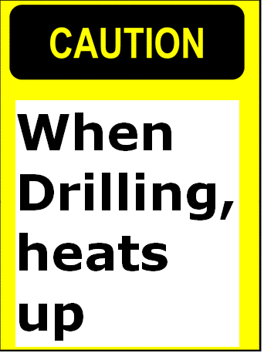 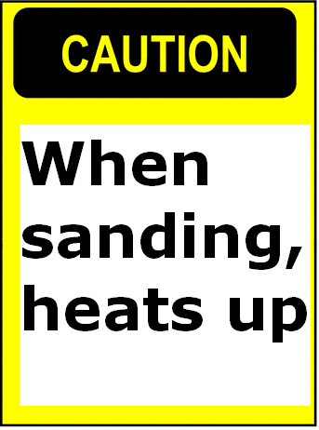    No, Info. No Pic.

The blanks

Wood Blanks Lists
A | B | C | D | E | F | G | H | I | J | K | L | M | N | O | P | Q | R | S | T | U | V | W | X | Y | Z

Wood (spalted) Blanks Lists
A | B | C | D | E | F | G | H | I | J | K | L | M | N | O | P | Q | R | S | T | U | V | W | X | Y | Z

Non-wood
Alternative Blanks Lists
A | B | C | D | E | F | G | H | I | J | K | L | M | N | O | P | Q | R | S | T | U | V | W | X | Y | Z

No, Info. No Pic. No Pic. Of the blank or pen. No Pic. Of pen.

Wood Blanks
Acacia (Shittam-Old World)  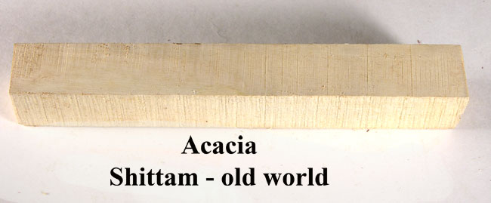  No, Info. | African Blackwood  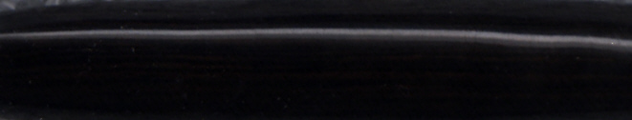  No Pic. Of the blank or pen. | Amboyna  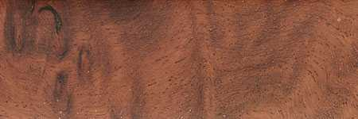Amboyna 50% Burl  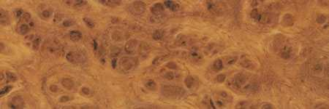Amboyna 100% Burl  No Pic. of pen. | Asian Ironwood Burl  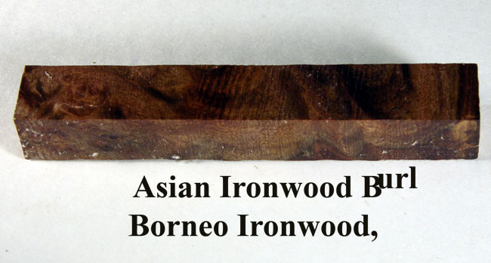  No, Info.
Banksia Pod Blank  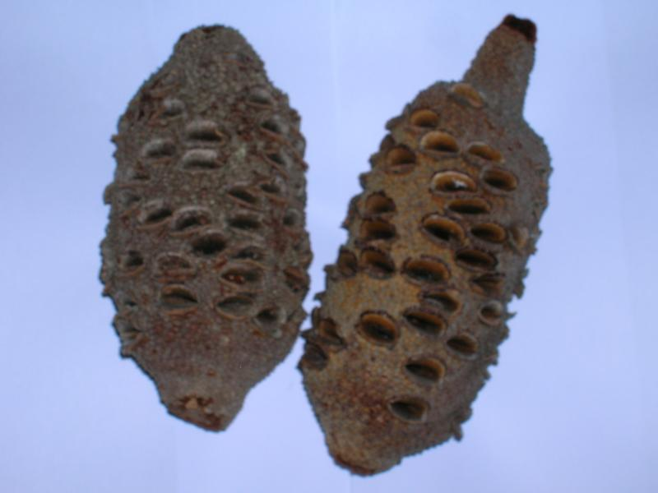  No Pic. Of the blank or pen. | Bethlehem Olive Wood  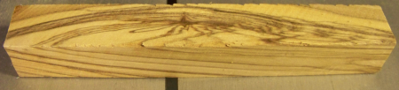  No Pic. Of the blank or pen. | Birdseye Maple  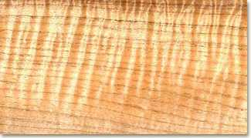  ✓ | Black Palm  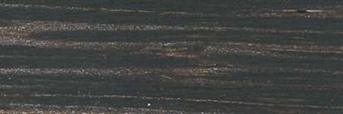  No Pic. Of pen
Blood wood  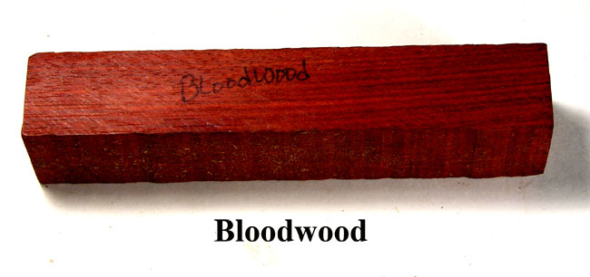  No, Info. No Pic. Of pen. | Buckeye Burl  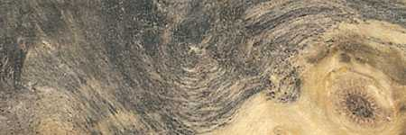  No Pic. Of pen
Camphor  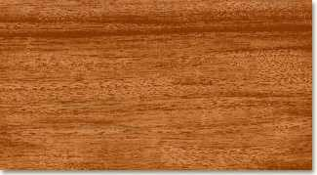  No Pic. Of pen. | Cedar (Alaskan yellow)  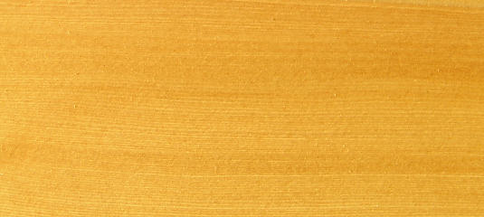  No Pic. Of pen. | Cocobolo  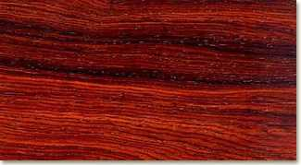  No Pic. Of pen. | Coolibah Burl  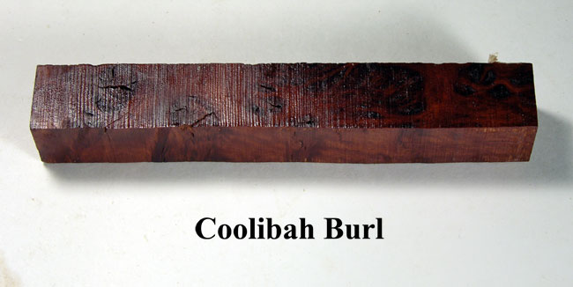  No Pic. Of pen.
Corrugata burl
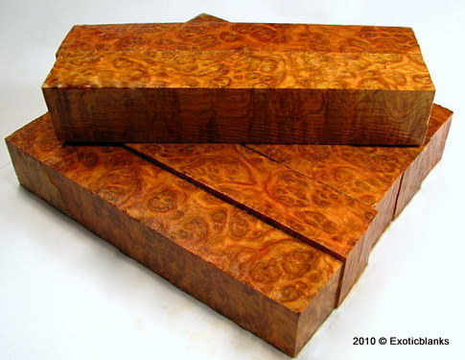 ✓
Desert Ironwood (Arizona)  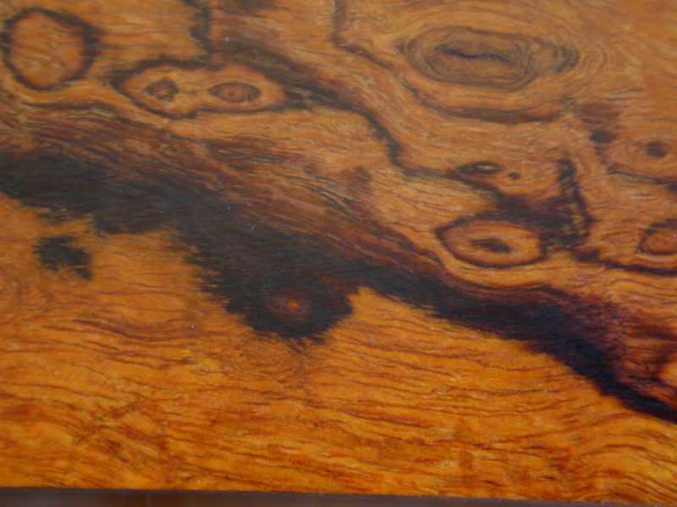  No Pic. Of pen. | Douglass Fir Burl  No Pic. Of the blank or pen
Ebony Black (Gabon Ebony)  No Pic. Of pen.  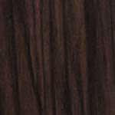 | Ebony Black & White  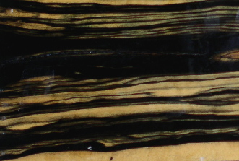  ✓ | Ebony Brazilian  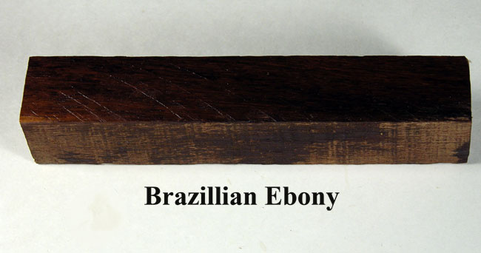  No, Info.
Grenadilla with Sap Wood
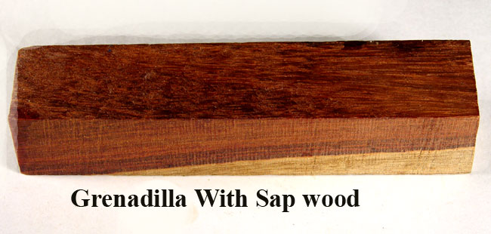
No Pic. Of pen.

Hairy She Oak
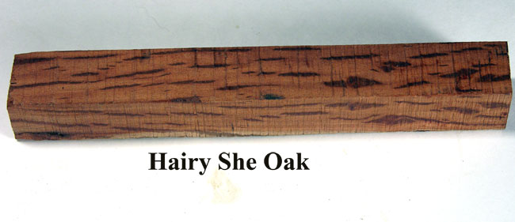
No, Info.
Kingwood  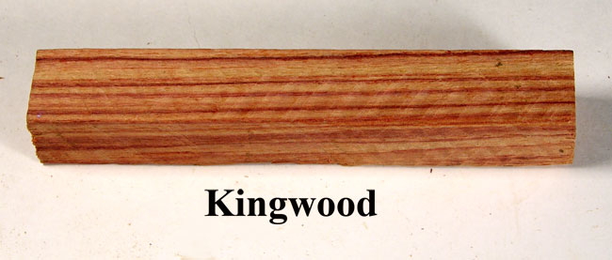  No Pic. Of pen. | Koa/Curly Koa  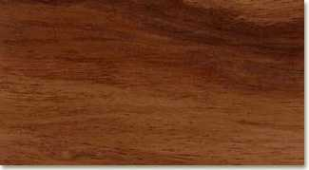  ✓ | Koa, Fiddleback  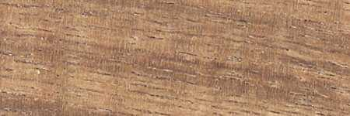
Locust (crotchwood)

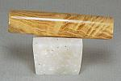
No Pic. Of pen.

Macamacuba (Maca wood),  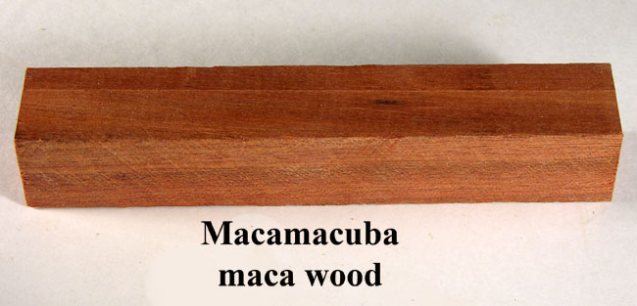  No, Info. |  | Mahogany (Honduras)  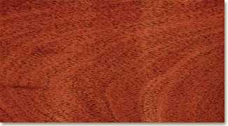
Maple (Birdeye)  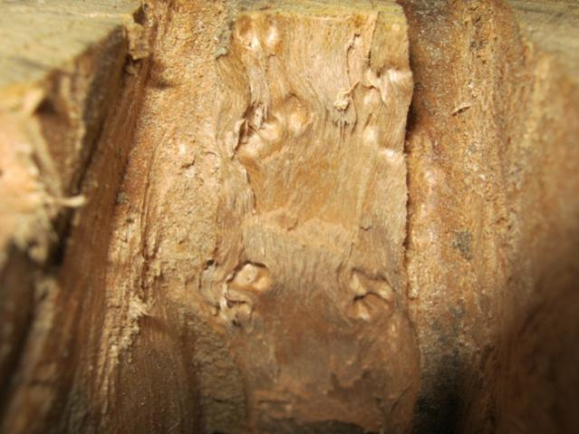 | Maple Curley  ✓ | Quilted Maple  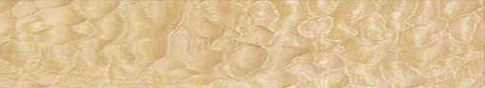  ✓ | Ambrosia (sugar) Maple  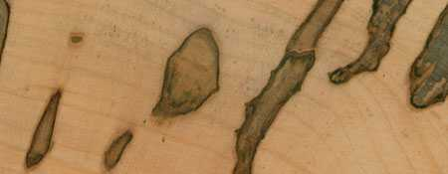  ✓
Marbel wood  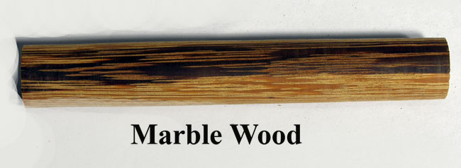  No, Info. | Mulberry ????  No Pic.
Up to here
Oak (Red)  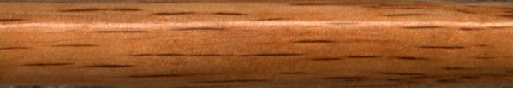 |  | (White (Jack Daniels Blank))?? | Osage Orange  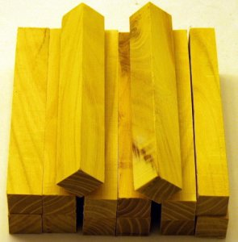
Oak (White)

No Pic.
Padauk   | Pink ivory  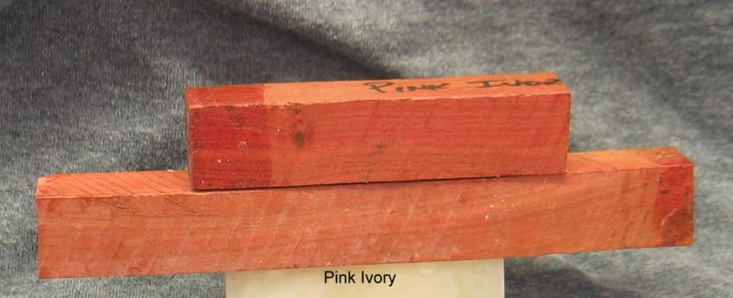 | Pistachio | Purpleheart  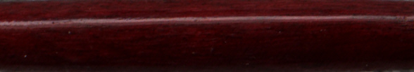  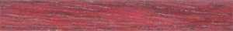
Red Cedar (eastern)  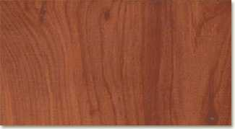 |  | Red Mallee Burl  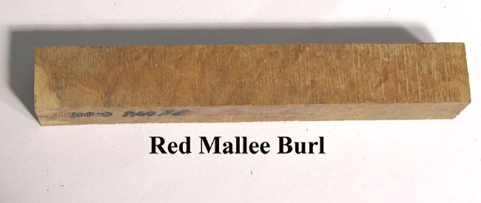 | Red Oak(See Oak(red))
Red Palm  No Pic. | Red heart  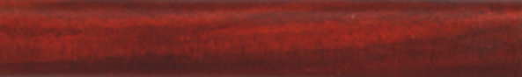 | Rosewood (East Indian)  No Pic.
Rosewood Honduras
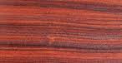
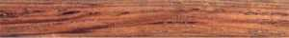
Sassafras
No Pic.
Tiete Rosewood (Amazon Rosewood)
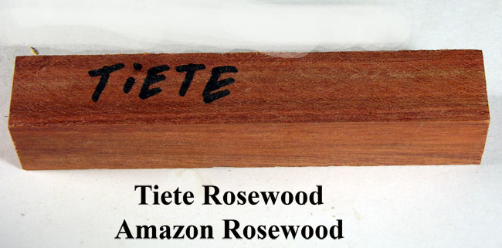
Walnut  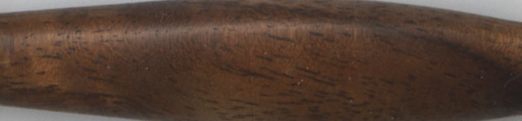  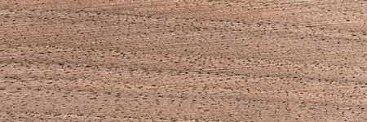 | Turkey Foot Pinon (Pinyon)  No Pic. | White Oak (see OAK)
Wenge

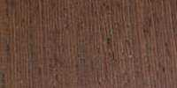
Zebra Wood  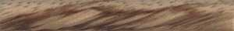 | Zircote  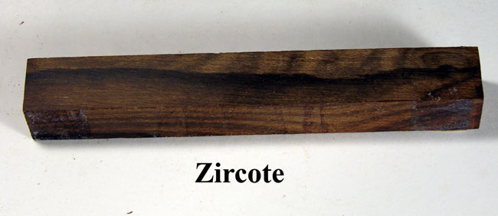

Wood (spalted) Blanks
Katalox (Spalted)
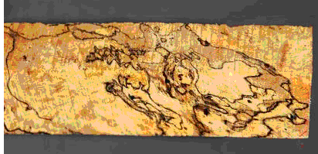
Maple(spalted)
Sassafras (Spalted)
No Pic.

Non-wood Blanks
Alabaster (white) (non-wood)  No Pic. | Alternative ivory (non-wood)  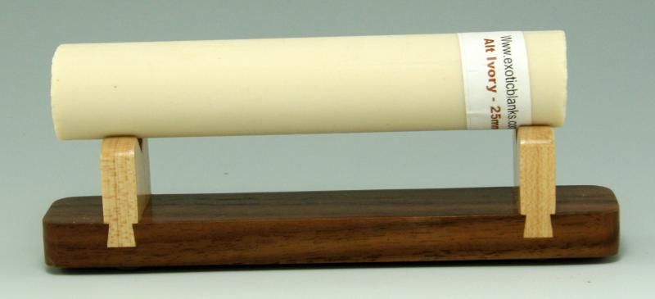 | Deer Antler (non-wood)  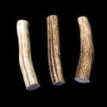
Casein (non-wood)  No Pic. | Corn Cob  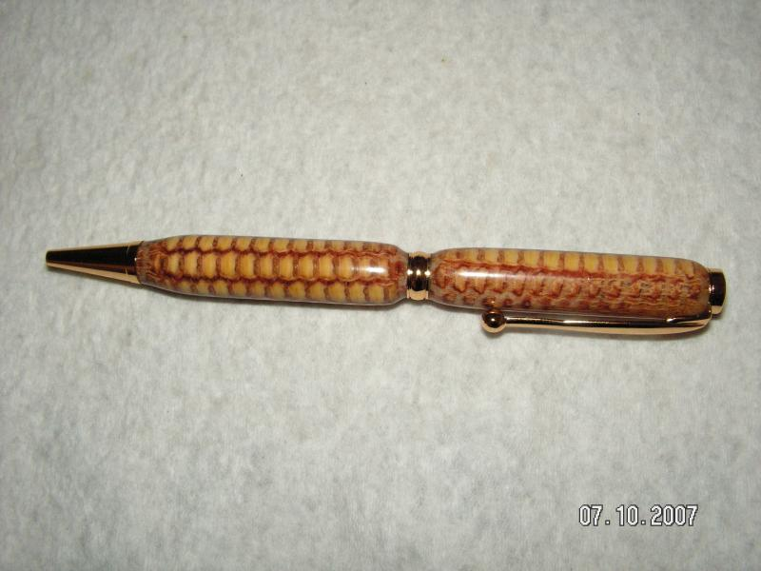
Ebonite (non-wood)

No Pic.
Inlace Arylester
Leather (non-wood)
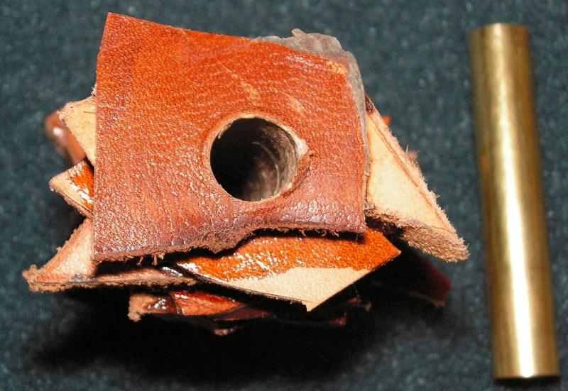

M3 Cobalt Blue (non-wood)
Polymer Clay
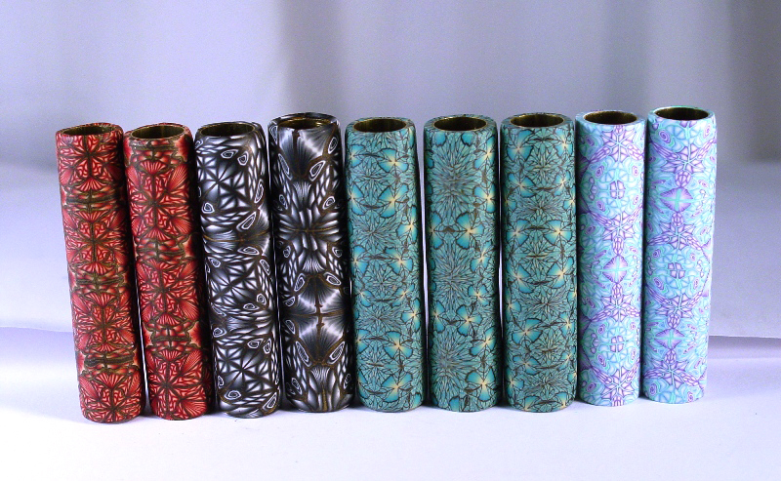

Wood Blanks

Member Avatar | Bitshird
Blank Name | Acacia (Shittam-Old World)
Blank picture Before turning | Courtesy of bitshird (BIS)
Blank picture After turning or rounding it off
Link to or picture of a sample pen | http://leapwood-pens.com/Asian%20Ironwood%20Cigar.htm
Link for a sample pen
Species of the blank | Eusideroxylon zwageri
What did you like, or dislike about the blank | Like (special Characteristics)  - Color and grain pattern, very hard and dense wood  Dislike (special Characteristics);  - Some difficulty in drilling
Was the blank harvested and dried by you, or kiln dried? | Kiln Dried
Does the (wood) blank need to be stabilized? | No
Is the wood known to be hazardous to touch, or skin? | Not particularly
Are the wood particles or dust known to be hazardous to inhale? (irritant, Caustic) | Any wood dust is hazardous ,
Did you use an alternative tool because of the nature of wood fiber to achieve a better result? (Carbide cutter tool, flap sander, etc.) ? If yes, please state | I used a Woodchuck Carbide tool
Did you use any special care for drilling? | Medium RPM about 750 RPM and light pressure, to prevent heat build up
Any special care for sanding (Dry/Wet, slow speed)? | Dry sanded to 600
What finish did you use? Any problems applying it? | CA no particular problems
Were there any problems with the blank after it was finished, cracks, cloudy finish,dull finish ...? | No
Did you use polishing or buffing? | Chrome Oxide “Zam”
Additional information to add  Top | The wood is endangered due to over harvesting in Borneo and Indonesia

Member Avatar | bradh -aka HardingPens (BR) ✓
Blank Name | African Blackwood
Blank picture Before turning
Blank picture After turning or rounding it off
Link to or picture of a sample pen
Species of the balnk | Dalbergia melanoxylon, (BR)
What did you like, or dislike about the blank | Like: When you get the finish right, this wood makes stunning pens. Very dark wood, the grain comes to life in bright light or sunlight., (BR)  Dislike: Very hard wood and dulls tools quickly. Sometimes the wood is so dark it looks like plastic., (BR)
Was the blank wet, dry, kiln dry? | Kiln dried, (BR)
Does the (wood) blank need to be stabilized? | No, (BR)
Is the wood known to be hazardous to touch? | No, (BR)
Are the wood particles or dust known to be hazardous to inhale? | No, (BR)
Did you use the gouge? | Yes, (BR)
Did you use the skew? | Yes, (BR)
Did you use an alternative tool? (carbide cutter tool, flap sander, etc.) ? If Yes, please sate
Did you use any special care for drilling? | Drill slowly and clear chips often, this blank generates a lot of heat when drilled., (BR)
Is the blank hard to sand? | No, (BR)
What finish did you use? Any problems applying it? | No.  This wood is full of oils that will cloud a CA finish. I wipe the blank with acetone after sanding and before the first CA coat., (BR)
Were there any problems with the blank after it was finished , cracks,cloudy finish,dull finish ...? | Sometimes the CA finish will turn dull often in patches, after a day or two from the oils in the wood. If this happens, strip the CA off with acetone and start again., (BR)
Did you use polishing or buffing? | I always MM to 12000 then buff my finishes for high gloss, (BR)
Additional information to add  Top | This wood is very hard and takes very sharp tools to cut well. Tools dull quickly and re-sharpening is often needed. This is one of the most difficult woods to get a good CA finish on, removing oils before the CA finish is important. Other finishes, such as Lacquer or poly are often easier to apply. This wood is common in exotic wood dealers, but expensive. It is common to see blanks with sapwood which is yellow to light creamy coloured creating a dramatic contrast., (BR)

Member Avatar | - JBCustomPens (JBC) ✓  - phillywood (PW)
Blank Name | Amboyna Burl  Picture bellow Courtesy of: rjwolfe3 (RW)  Amboyna 50% Burl  Amboyna 100% Burl
Blank picture Before turning
Blank picture After turning or rounding it off
Link to or picture of a sample pen
Species of the blank | Pterocarpus indicus, (JBC)
What did you like, or dislike about the blank | Like:  - Nice smell, looks great., (JBC)  - Beautifully eyed figured blank, Its reddish color (PW)  Dislike:  - some small cracks in the eyes, it is very easy to crack the end of the blanks if you are not careful. (PW)
Was the blank wet, dry, kiln dry? | Kiln dry., (JBC), (PW)
Does the (wood) blank need to be stabilized? | - No, the blank can turn just fine without stabilization., (JBC)  - Mine was stabilized and it seems that stabilization helps for he better finish and easier turning. (PW)
Is the wood known to be hazardous to touch? | No., (JBC), (PW)
Are the wood particles or dust known to be hazardous to inhale? | - No., (JBC),  - No, but I recommend to wear safety mask for those with allergies. (PW)
Did you use an alternative tool? (Carbide cutter tool, flap sander, etc.) ? If Yes, please sate | - No. , just spindle gouge, and skew (JBC)  - I used carbide cutter at first then finished with ????? (PW)
Did you use any special care for drilling? | No, drills great., (JBC)  Yes, used ?????? which dramatically assist in not getting the balnks hot and therefore cracking. (PW)
Is the blank hard to sand? | No, sandpaper clogs up a little., (JBC), (PW)
What finish did you use? Any problems applying it? | I used CA, and it went on great., (JBC)  CA
Were there any problems with the blank after it was finished cracks, cloudy finish, dull finish ? | Not at all, and if they were they were my own fault., (JBC)
Did you use polishing or buffing? | I polished with a rag with nothing on the rag, and it was after CA.., (JBC)
Additional information to add  Top | Amboyna is one of my favorite woods, turns great, and with some patience and maybe some filling of eyes with CA, it is one of the most beautiful known woods., (JBC)

Member Avatar | (Please erase this line and enter your IAP handle here)
Blank Name | Asian Ironwood Burl
Blank picture Before turning | Courtesy of bitshird (BIS)
Blank picture After turning or rounding it off
Link to or picture of a sample pen | 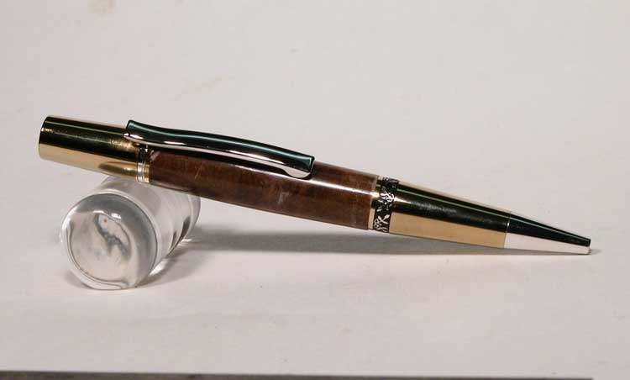 Courtesy of bitshird (BIS) (from post dated: 02-11-2009)
Species of the blank
What did you like, or dislike about the blank | Like (special Characteristics):  Dislike (special Characteristics);
Was the blank harvested and dried by you, or kiln dried?
Does the (wood) blank need to be stabilized?
Is the wood known to be hazardous to touch, or skin?
Are the wood particles or dust known to be hazardous to inhale? (irritant, Caustic)
Did you use an alternative tool because of the nature of wood fiber to achieve a better result? (Carbide cutter tool, flap sander, etc.) ? If yes, please state
Did you use any special care for drilling?
Any special care for sanding (Dry/Wet, slow speed)?
What finish did you use? Any problems applying it?
Were there any problems with the blank after it was finished, cracks, cloudy finish,dull finish ...?
Did you use polishing or buffing?
Additional information to add
Top

- Top

Member Avatar | diver123 (DIV) 8/24/10 10:15 PM
Blank Name | Banksia Pod Blank  Two Banksia Pods in the raw  vase I turned (voids as well as some of the holes I filled in with red enlace)  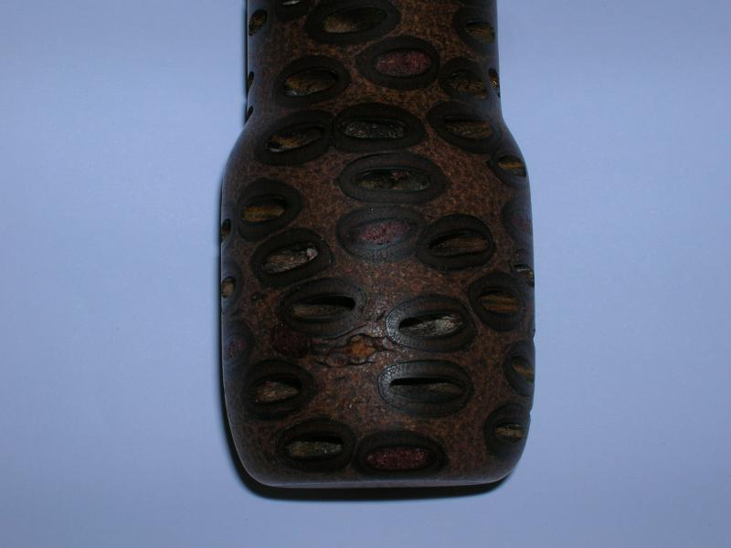
Species of the blank
Link for a sample pen
What did you like, or dislike about the blank | - Like: Makes a very unique and attractive vase, pen, etc.  - Dislike: The seed voids can be large and need to be filled with something. IE. Coffee grounds or enlace. Time consuming.
Was the blank harvested and dried by you, or kiln dried? | no. Come dried
Does the (wood) blank need to be stabilized? | no
Is the wood known to be hazardous to touch, or skin? | no
Are the wood particles or dust known to be hazardous to inhale? (irritant, Caustic) | no but wear a mask. Makes a mess! Worse than anything
Did you use an alternative tool because of the nature of wood fiber to achieve a better result? (Carbide cutter tool, flap sander, etc.) ? If yes, please state | no but is very hard.
Did you use any special care for drilling? | none
Any special care for sanding (Dry/Wet, slow speed)? | No. Sands well and to a nice luster
What finish did you use? Any problems applying it? | Varnish.
Were there any problems with the blank after it was finished, cracks, cloudy finish,dull finish ...? | Soaks up finish some.
Did you use polishing or buffing? | no
Additional information to add

Top

Member Avatar | ToddMR (TM) 09-15-2010, 09:40 AM
Blank Name | Bethlehem Olive Wood
Blank picture Before turning
Blank picture After turning or rounding it off
Link to or picture of a sample pen
Species of the blank
What did you like, or dislike about the blank | Like (special Characteristics)  - Normally very nice grain and super easy to turn. Soft wood which makes drilling easy. Very easy to sand and polishes nicely.  Dislike (special Characteristics)  - Oily so doing a finish can be challenging.
Was the blank wet, you dried it, kiln dry? | Dry
Does the (wood) blank need to be stabilized? | No
Is the wood known to be hazardous to touch? (give rash or hives) | Not that I know of.
Are the wood particles or dust known to be hazardous to inhale? (irritant, caustic) | all wood dust is
Did you use an alternative tool? (carbide cutter tool, flap sander, etc.) ? If Yes, please sate | No
Did you use any special care for drilling? | No
Is the blank hard to sand? | No
What finish did you use? Any problems applying it? | CA. The trick is to either use DNA to wipe the blank after initial sanding, or spray and wipe with accelerator. I then do 2 coats thin ca as a sealer, then work up the med. ca.
Were there any problems with the blank after it was finished , cracks,cloudy finish,dull finish ...? | None
Did you use polishing or buffing? | None
Additional information to add  Top | When I drill the wood I can smell olives. It is kind of a cool smell. Also these normally come with a certificate of authenticity.

Member Avatar | Soligen (SOL), ✓ Alexanderpens (AP) 08-17-2010, 10:57 PM ✓   Scotty (SC) 08-18-2010, 03:02 PM ✓ ed4copies (ED) 08-18-2010, 08:43 AM ✓  Seer(SR) 08-18-2010, 08:22 AM ✓ rjwolfe3 (RW) 08-18-2010, 07:02 AM
Blank Name | Black Palm
Blank picture Before turning | Picture courtesy of Soligen (SOL)  Picture courtesy of rjwolfe3
Blank picture After turning or rounding it off
Link to or picture of a sample pen
Species of the blank | Black Palm
A sample pen | 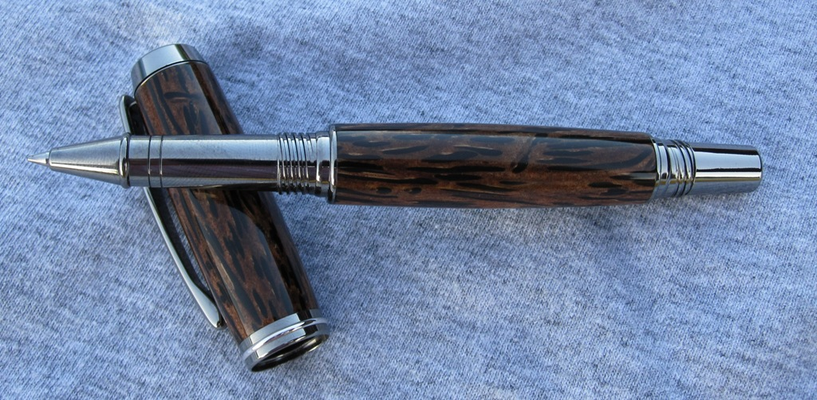 (SOL)
What did you like, or dislike about the blank | Like:  - Interesting look. Black tubes on lighter background. Challenging to turn., (SOL)  - Beautiful grain (RW)  - Beautiful to turn. Drills easy. (AP)  Dislike:  - Cracks a little easier than most. (AP)  - Very hard to work with. Falls apart easily. Splinters when turning and hurts when splinters hit you. (RW)
Was the blank wet, dry, kiln dry? | - Dry - unknown method, (SOL)  - I got it from someone else so not sure but it was dry(RW)  - No (AP)
Does the (wood) blank need to be stabilized? | - No, but it may make it easier to turn, (SOL)  - Would turn better in my opinion. (RW)  - Only if you want to (AP)
Is the wood known to be hazardous to touch, skin? | - So far it is the only wood I have turned that gave me a rash. I turned some while in Brazil and my arms broke out from the dust and shavings hitting my arms. CA does help when turning it. (SC)  - Not to my knowledge(RW)
Are the wood particles or dust known to be hazardous to inhale? (irritant, Caustic) | yes should use some type of dust protection
Did you use the gouge, skew? | No, (SOL)
Did you use an alternative tool because of the nature of wood fiber to achieve a better result? (Carbide cutter tool, flap sander, etc.) ? If yes, please state | - Used a parting tool - sharp as possible to nibble off 1/16 at a time, (SOL)  - I did not try but I think a carbide cutter would work much better. Will try that next(RW)
Did you use any special care for drilling? | - No, (SOL)  - Drilled slow (RW)  - Drills like butter. (AP)
Any special care for sanding (Dry/Wet, slow speed)? | - No, (SOL)  - had a hard time getting to this stage(RW)  - Leave a little more before sanding to reduce nicks and turn lines. (AP)
What finish did you use? Any problems applying it? | - CA, (SOL)  - never got this far(RW)  - Nat oil for cleaning the pores, and just a finish of choice (AP)
Were there any problems with the blank after it was finished, cracks, cloudy finish, dull finish ...? | - Depends on experience. I only turned successfully once. Cracks may be a tad common. Practice = close to perfect! (AP)  - did not complete blank yet(RW)
Did you use polishing or buffing? | - Buffing, (SOL)  - did not complete blank yet (RW)  - renaissance wax. (AP)
Additional information to add | - Tears out easily. Sanded with 80 grit for final shape. Nibbling with the parting helps keep the hard tubes from breaking off.  Repeated soaking with thin CA while turning helps prevent tear out  Lighter color pith is soft and weak and black tubes hard and dense, so the blank is prone to break off the tube when turned thin. Using an expanding polyurathane glue to get 100% coverage seems to help with this., (SOL)  - Wood is not for beginners. Very hard to work with and very frustrating. But I hear the results are worth it so will revisit it in the future. (RW)  - Striking on the perfect kit, a wow factor on others. Definitely a beautiful wood! (AP)  - if you drip thin CA in the "faced" ends, it will reinforce the ends, removing SOME of the difficulty in turning Palm--black red or white, they all have a very coarse grain and are subject to catches and "blow outs".  As you near final size, reinforcing with thin CA is suggested. This might imply it would be good to have it stabilized---I have never SEEN stabilized Palm---don't know why. (ED)  - Only thing I would add is use a lot of thin CA while turning it will keep the blank together and actually stabilize it and give you a CA finishes that polishes nicely. (SR)  Top

Member Avatar | bradh -aka HardingPens (BR) ✓
Blank Name | Black Walnut 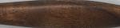
Species of the balnk | Juglans nigra, and a few similar Juglans spp. (BR)
What did you like, or dislike about the blank | Like: The wood is easy to work with and finishes easily. Beautiful dark colour. (BR)  Dislike: A little more expensive and harder to find than most NA hardwoods, but still readily available through better wood dealers. (BR)
Was the blank wet, dry, kiln dry? | Kiln dried, (BR)
Does the (wood) blank need to be stabilized? | No, (BR)
Is the wood known to be hazardous to touch? | No, the wood shavings are believed to be dangerous to use for animal bedding and has been known to harm plants if used as mulch., (BR)
Are the wood particles or dust known to be hazardous to inhale? | No, (BR)
Did you use the gouge? | Yes, (BR)
Did you use the skew? | yes, (BR)
Did you use an alternative tool? (carbide cutter tool, flap sander, etc.) ? If Yes, please sate | no, (BR)
Did you use any special care for drilling? | no, (BR)
Is the blank hard to sand? | no, (BR)
What finish did you use? Any problems applying it? | CA or CA/BLO, both work well and finish easily.  no, (BR)
Were there any problems with the blank after it was finished , cracks,cloudy finish,dull finish ...? | no, (BR)
Did you use polishing or buffing? | I always MM to 12000 then buff my finishes for high gloss. , (BR)
Additional information to add | This wood is a little more difficult to find than other NA hardwoods, but is usually available from any exotic wood dealer. The medium to dark brown color is very distinct and beautiful. A popular choice for customers who want a darker wood color. , (BR)  Top

Member Avatar | (Please erase this line and enter your IAP handle here)
Blank Name  (A picture of the blank before you turned it or if you have another one similar to it) | Blood wood  Courtesy of bitshird (BIS)
Link for a sample pen
Species of the blank
What did you like, or dislike about the blank | Like (special Characteristics):  - A  Dislike (special Characteristics);
Was the blank harvested and dried by you, or kiln dried?
Does the (wood) blank need to be stabilized?
Is the wood known to be hazardous to touch, or skin?
Are the wood particles or dust known to be hazardous to inhale? (irritant, Caustic)
Did you use an alternative tool because of the nature of wood fiber to achieve a better result? (Carbide cutter tool, flap sander, etc.) ? If yes, please state
Did you use any special care for drilling?
Any special care for sanding (Dry/Wet, slow speed)?
What finish did you use? Any problems applying it?
Were there any problems with the blank after it was finished, cracks, cloudy finish,dull finish ...?
Did you use polishing or buffing?
Additional information to add
Top

Member Avatar | rjwolfe3 (RW), ✓
Blank Name | Buckeye Burl
Blank picture Before turning | Picture Courtesy of: rjwolfe3 (RW)
Blank picture After turning or rounding it off
Link to or picture of a sample pen
Species of the blank | Buckeye
What did you like, or dislike about the blank | Like (special Characteristics): Turned easily if stabilized. Looks awesome. (RW)  Dislike (special Characteristics): Very weak if not stabilized, needs CA to hold together. (RW)
Was the blank wet, you dried it, kiln dry? | Dry but not sure how. (RW)
Does the (wood) blank need to be stabilized? | Turns easier if it is. (RW)
Is the wood known to be hazardous to touch? (give rash or hives) | Not to my knowledge but best to wear PPE. (RW)
Are the wood particles or dust known to be hazardous to inhale? (irritant, caustic) | Not to my knowledge but best to wear PPE. (RW)
Did you use an alternative tool? (carbide cutter tool, flap sander, etc.) ? If Yes, please sate | I always use carbide cutter tools but I have used a skew as well. (RW)
Did you use any special care for drilling? | Only if not stabilized(RW)
Is the blank hard to sand? | No(RW)
What finish did you use? Any problems applying it? | If not stabilized any voids and cracks will need filled in before applying finish. (RW)
Were there any problems with the blank after it was finished , cracks,cloudy finish,dull finish ...? | No, not yet. (RW)
Did you use polishing or buffing? | I polished the finish but not the wood. (RW)
Additional information to add  Top | Wood is beautiful to use. Can be turned either stabilized or not but turns much easier stabilized. Lots of stabilized blanks are also died. (RW)

Member Avatar✓ | - bitshird aka Ken Ferrell (BIS)  - rjwolfe3 (RW)  - CSue (CS)  - bruce119(BR1)
Blank Name | Camphor
Blank picture Before turning | Picture Courtesy of: rjwolfe3 (RW
Blank picture After turning or rounding it off
Link to or picture of a sample pen
Blank specie | - Cinnamomum camphora(BIS) (CS)
What did you like, or dislike about the blank | Like: (special Characteristics)  - The scent while cutting, and the ease of cutting and finishing (BIS)  - Love the smell, (RW)  Dislike: (special Characteristics)  - but it is a soft wood to work with (RW)  - The aroma is quite pungent and some may find it leaves a burning sensation if inhaled through mouth.(CS)  - Very strong distinct odor. The smell is like opening up a jaw of Ben gay. The first few times you like it after working with it for 2 weeks straight you hate it. (BR1)
Blank needs be stabilized? | - no(BIS)  - it may make it easier to tool (RW)  - no(CS)  - NO very stable hard wood(BR1)
Wood known to be hazardous to touch or skin (your reaction only)? | - None, but is listed as an irritant(BIS)  - no reaction to touch or skin (RW)  - no(CS)  - …….(BR1)
This wood particle or dust known be hazardous to inhale (if you know of)? | - (BIS)  - can be (RW)  - It may leave taste buds with burning sensation as does hot chili peppers. For me, the burning sensation stayed with me for few days.(CS)  - If worked with enough you can develop a sinus reaction(BR1)
Tool you would not recommend to use with That will ruin the blank? (gouge, carbide cutter tool, flap sander, etc.)(your experience only) | - Carbide Woodchuck Pen Pro(BIS)  - none (RW)  - none (CS)  - No normal tools(BR1)
Any special care for drilling? | - No(BIS)  - may need slow drilling (RW)  - Go slowly and carefully, as bit will heat up quickly. (CS)  - no(BR1)
Any special care for sanding (Dry/Wet, slow speed)? | - Dry sand(BIS)  - dry sand wood, wet sand finish, normal speed (RW)  - Go slowly - little bit at a time (CS)  - no(BR1)
Finish used? | - CA(BIS)  - (RW)  - polyacrylic or varnish (CS)  - any(BR1)
Any problems when applying it? | - No(BIS), (RW), (CS), (BR1)
Any problems after Blank finished (Ex.. cracks, cloudy, dull finish ...?, or during assembly | - No(BIS)  - No(RW)  - this is a very oily wood  - NO very stabile(BR1)
Used polishing or buffing? | - Chromium Oxide (Zam) (BIS)  - …………  - only on finish(CS)  - (BR1)
Additional information you like to add  Top | - the color, the smell and the beautiful way it ages make this a great wood, I particularly like it for small bowls and special tool handles, (BIS)  - Makes the whole shop smell great when working with. Wood will mildew easily when freshly cut. also can have awesome color variations in same blank (RW)  - I've only had access to Cinnamon Burl wood and "Camphor" burl. It is hard to drill and quite oily. But the color is beautiful! "Camphor" itself is actually the white crystaline substance derived from the wood and used in many different ways for thousands of years (CS)  - Can be a very nice wood good figure with tones of red and yellows (BR1)

Member Avatar | RyanNJ (RNJ) 8/25/10 08:23 AM
Blank Name | Alaskan Yellow Cedar
Blank picture Before turning | Courtesy of http://www.woodfinder.com
Blank picture After turning or rounding it off
Link to or picture of a sample pen
Blank specie | Callitropsis nootkatensis
What did you like, or dislike about the blank | Like: (special Characteristics)  Very easy to turn and accepts a CA finish without issues. very fast to drill and turn
Blank needs be stabilized? | No
Wood known to be hazardous to touch or skin?
Wood particles or dust known be hazardous to inhale? | Likely
Tool you would not recommend to use with? (gauge, carbide cutter tool, flap sander, etc.) | Gouge, Skew, Carbide all work well.
Any special care for drilling? | No
Any special care for sanding (Dry/Wet, slow speed)? | dry
Finish used? | BLO/CA
Any problems when applying it? | None
Any problems after Blank finished (ex. cracks,cloudy, dull finish ...?, or during assembly | only problem was a spot where my towel caught when applying the finish
Used polishing or buffing? | HUT Wax and then Flitz metal polish
Additional information you like to add  Top | This is not a cedar blank, it is actually from a cypress tree

Member Avatar | Snyiper (sny) ✓
Blank Name | Cocobolo
Blank picture Before turning | Picture Courtesy of: rjwolfe3 (RW)
Blank picture After turning or rounding it off
Link to or picture of a sample pen
Blank specie | Dalbergia retusa, (sny)
What did you like, or dislike about the blank | Nice grain, hard wood dust seems to bother most
Blank needs be stabilized? | No very dense wood
Wood known to be hazardous to touch or skin? | I would say yes by my personal use take all precautions using this wood.
Wood particles or dust known be hazardous to inhale? | Yes I would use a mask with organic filter minimum
Tool you would not recommend to use with? (gauge, carbide cutter tool, flap sander, etc.)? | I used a fingernail scraper a carbide tool and skew, (sny)
Any special care for drilling? | Go slow clear often , (sny)
Any special care for sanding (Dry/Wet, slow speed)? | I dry sanded to 500, (sny)
Finish used? | BLO/CA. , (sny)
Any problems applying it? | None. , (sny)
Any problems after Blank finished (Ie. cracks, cloudy, dull finish ...? | None. , (sny)
Use polishing or buffing? | Green rouge and soft cotton wheel, (sny)
Additional information you like to add | Top

Member Avatar | (Please erase this line and enter your IAP handle here)
Blank Name  (A picture of the blank before you turned it or if you have another one similar to it) | Coolibah Burl  Courtesy of bitshird (BIS)
Link for a sample pen
Species of the blank
What did you like, or dislike about the blank | Like (special Characteristics):  - A  Dislike (special Characteristics);
Was the blank harvested and dried by you, or kiln dried?
Does the (wood) blank need to be stabilized?
Is the wood known to be hazardous to touch, or skin?
Are the wood particles or dust known to be hazardous to inhale? (irritant, Caustic)
Did you use an alternative tool because of the nature of wood fiber to achieve a better result? (Carbide cutter tool, flap sander, etc.) ? If yes, please state
Did you use any special care for drilling?
Any special care for sanding (Dry/Wet, slow speed)?
What finish did you use? Any problems applying it?
Were there any problems with the blank after it was finished, cracks, cloudy finish,dull finish ...?
Did you use polishing or buffing?
Additional information to add
Top

Member Avatar | ed4copies (ED) 9-06-2010, 07:35 PM
Blank Name | Corrugata Burl (ED)
Blank picture Before turning | Courtesy of: ed4copies (ED)
Blank picture After turning or rounding it off
Link to or picture of a sample pen | 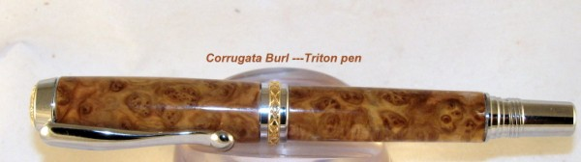  Courtesy of: ed4copies (ED)
Species of the blank | Corrugata Burl
What did you like, or dislike about the blank | - Like  Had great figure, lots of eyes, beautiful!! (ED)  - Dislike
Was the blank harvested and dried by you, or kiln dried?
Does the (wood) blank need to be stabilized? | No (ED)
Is the wood known to be hazardous to touch, or skin? | Not that I am aware of (ED)
Are the wood particles or dust known to be hazardous to inhale? (irritant, Caustic) | No, but dust collector was used while turning and sanding (ED)
Did you use an alternative tool because of the nature of wood fiber to achieve The best result? (Carbide cutter tool, flap sander, etc.) ? If yes, please state | Any should work, I used skew (ED)
Did you use any special care for drilling? | No (ED)
Any special care for sanding (Dry/Wet, slow speed)? | No special—sanded at 1500 rpm, with dust collector on (ED)
What finish did you use? Any problems applying it? | CA (Cyanoacrylic glue). No (ED)
Any problems after Blank finished such as (cracks, cloudy finish, dull finish, etc.? Or, during assembly? | Yes, turned cloudy next day---possibly wood was too green, did not check moisture before turning. (ED)
Did you use polishing or buffing? | Polish and buff with Tripoli and white diamond after CA coatings (ED)
Additional information to add  Top | Really spectacular pen, but CA is looking cloudy—suspect blank was not fully dry before turning. (ED)

Member Avatar | - Seer (SR) 08-12-2010, 09:47 AM  - bitshird (BIS) 08-10-2010, 09:09 AM
Blank Name | Desert Ironwood (Arizona)
Blank picture Before turning | Pictures are courtesy of Seer(SR)  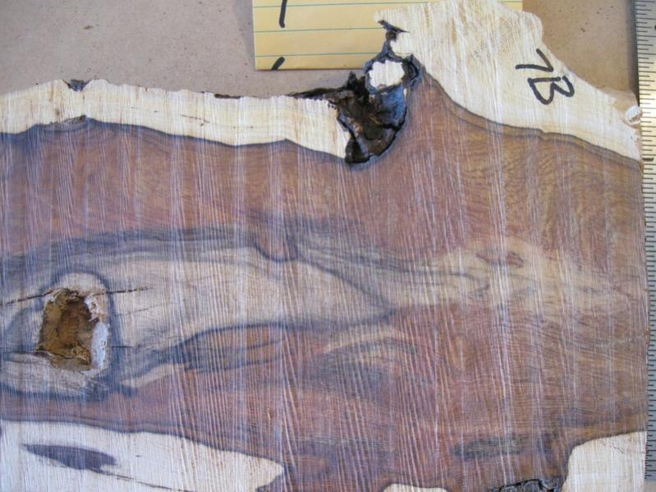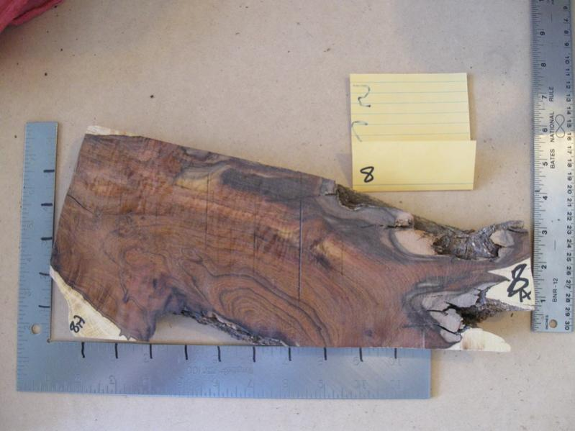  Picture bellow Courtesy of:  rjwolfe3 (RW)
Blank picture After turning or rounding it off
Link to or picture of a sample pen
Species of the blank | Olneya tesota(BIS)
What did you like, or dislike about the blank | Like (special Characteristics)  - Amazing grain Patterns and colors ranging from dark purples and browns to a gold like grain(SR)  - It is a beautiful dense wood chat is very hard. It will nearly take a polish without any sealants such as CA(BIS)  Dislike (special Characteristics)  - Smells like a wet dog(SR)  - Difficult to drill, and is sometimes oily(BIS)
Was the blank harvested and dried by you, kiln dried? | - Purchased logs already dried by nature(SR)  - No it and it was dried over several years(BIS)
Blank needs be stabilized? | - Not stabilized but it does have voids that need to be filled like a piece of Worthless Wood(SR)  - NO(BIS)
Wood known to be hazardous to touch or skin? | - No (SR)  - Dust from this wood is reported to irritate the nose and eyes(BIS)
Wood particles or dust known be hazardous to inhale? (irritant, Caustic) | Irritant(BIS)
Did you use an alternative tool because of the nature of wood fiber to achieve a better result? (Carbide cutter tool, flap sander, etc.) ? If yes, please state | - I have 3 round nose scrapers that work amazingly well on the wood but I use all 3 in the course of a 2 piece pen. (SR)  - Carbide Woodchuck (BIS)
Any special care for drilling? | - Same as any wood slow and do not over heat it. I have never had any issues drilling it. (SR)  - Yes Low RPM and light pressure to avoid building heat cracking the blank
Any special care for sanding (Dry/Wet, slow speed)? | - None I seal all mine with CA and wet sand. (SR)
What finish did you use? Any problems applying it? | - CA only(SR)  - CA after wiping the blank several times with Denatured Alcohol and a bit of accelerator CA when on nicely. (BIS)
Were there any problems with the blank after it was finished, cracks, cloudy, and dull finish ...? | - Not yet with CA but with friction polishes which I do not use anymore I had a couple of issues(SR)  - No(BIS)
Did you use polishing or buffing? | - Just wet sanding through the micromesh range after CA(SR)  - Yes Buffed with Chrome Oxide (ZAM)(BIS)
Additional information you like to add  Top | - A beautiful wood that will show off any kit used(SR)  - An exceptional beautiful wood when found with sap wood and heart wood mix, Even straight heart wood has beautiful grain (BIS)

Member Avatar | Mark (MK) 8/26/10, 04:59 PM
Blank Name | Douglass Fir Burl
Blank picture Before turning | will supply on next blank
Blank picture After turning | will supply on next blank
Link to a sample pen | 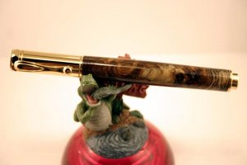 courtesy of Mark
Blank specie | Pseudotsuga menziesii (I think)
What did you like, or dislike about the blank | Like (special Characteristics)  I liked the smell when turning it.  Dislike (special Characteristics)  An abundance of sap collects on the tools at high temps.
Blank needs be stabilized? | No
Wood known to be hazardous to touch or skin? | No, but it is sticky
Wood particles or dust known be hazardous to inhale? | ?
Tool you would not recommend to use with? (gauge, carbide cutter tool, flap sander, etc.) | Gouge, skew or carbide work fine
Any special care for drilling? | No
Any special care for sanding (Dry/Wet, slow speed)? | Dry. Slower than normal to avoid excess heat. Heat makes the sap gum up.
Finish used? | CA
Any problems when applying it? | None
Any problems after Blank finished (ex. cracks,cloudy, dull finish ...?, or during assembly | None
Used polishing or buffing? | Polish. Will try buffing on next blank
Additional information you like to add  Top | I elected to cut slowly, due to the knots and burls in the blank. A sharp tool helps a lot with the turning.

Have to PM him and ask to explain gr8danish (GR8) 8/11/10
EBONY -, ,.
IVORY - is an absolutely wonderful material to cut, HOWEVER, be VERY careful when handling cut pieces of Ivory. It is a nasty material in the sense that if you cut yourself with it you will be guaranteed to get an infection. ***Make absolute sure to wear eye and inhalation protection. Imagine if it causes infection to an open wound what the dust would do to your lungs / eyes!
The Really nice thing about both Ebony & Ivory is that they FEEL the best unfinished (in my personal opinion). All you have to do is polish them out very well after they are cut to size. Ebony gets a nice natural oily luster, and Ivory will shine bright like polished plastic when polished correctly.
Believe it or not, I've had the best luck doing a final polish (actually a burnish to be precise) with a dry, white notecard or business card. Top
Member Avatar | - gr8danish (GD),  - Craftdiggity (Chris Merlino) (CD) 08-09-2010  - TellicoTurning (Chuck) (TT) 8-10-10
Blank Name | Ebony Black (Gaboon Ebony)  Picture bellow Courtesy of: rjwolfe3 (RW)
Species of the blank | Diospyrus Crassiflora
What did you like, or dislike about the blank | Like: (special Characteristics)  - The wood is mostly black with occasional grey streaks, fine texture and a straight to wavy grain. Sap wood is pale yellow and very distinct, but rarely seen. (please verify)  - It's very hard and dense(CD)  - nice tight grain, (GD),  - great wood to work with  Dislike: (special Characteristics)  This wood turns well, but a little hard on tools due to its density (please verify)  VERY dense, and oily(GD),
Did you dry it, or kiln dried? | - No matter which specie of Ebony you choose to work with, MAKE SURE THAT IT IS KILN DRIED. Don't even waste your time with the air-dried stuff(GD),  - You usually don't get a green piece in the U.S. (CD)
Does the (wood) blank need to be stabilized? | Doesn't need to be stabilized, although it is very prone to cracking(CD)
Is the wood known to be hazardous to touch? (give rash or hives)
Are the wood particles or dust known to be hazardous to inhale? (irritant, caustic) | The dust can be an irritant. Odor and taste are not distinct. (please verify)
Did you use an alternative tool? (carbide cutter tool, flap sander, etc.) ? If Yes, please sate | Not really. (CD)  Ebony can crack over time. It does not like temperature changes.  Polishes and buffs to a very high gloss.
Did you use any special care for drilling? | It definitely dulls edges and drill bits(CD)
Is the blank hard to sand? | no
What finish did you use? Any problems applying it? | - Takes a very high finish. (CD)  - Takes a finish although it can be a bit oily which might cause problems for lacquers. (CD)
Were there any problems with the blank after it was finished, cracks, cloudy finish, dull finish ...?
Did you use polishing or buffing?
Additional information to add  Top | It is too hard to use nails or screws without first pre-boring. (please verify)  - There are quite a few different species of Ebony. Gaboon ebony is the most desired, as it is the darkest BLACK in color.  - Macassar Ebony is a very dark brown, and usually has a heavy streaked pattern to it. It is not quite as dense as Gaboon, but is still fairly dense and oily. It has to be aged for YEARS before it is useable, and even then, you have to wait MONTHS sometimes in between cuts to prevent warping / cracking. (GD),  - The dust gets all over everything in the shop... and it smells like a wet cow barn to me when I turn it. (TT)

Member Avatar | - wdcav1952 (WCAV) 8/19/10 06:22 AM  - bitshird (BIS) 8/19/10 09:09 AM
Blank Name | Ebony Black & white by bitshird  Picture bellow Courtesy of: wdcav1952
Link for a sample pen | 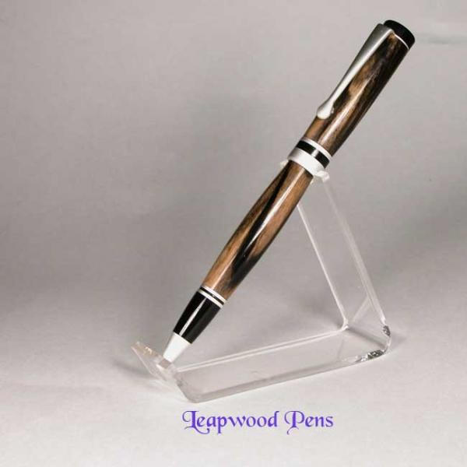  Courtesy of bitshird (BIS)
Species of the blank
What did you like, or dislike about the blank | Like: (special Characteristics)  - color (BIS)  Dislike: (special Characteristics)  - It tends to crack easily (WCAV), (BIS)  - the difficulty in turning (BIS)
Was the blank harvested and dried by you, or kiln dried? | Since this wood cracks easily we recommend special procedures for drying pieces thicker than 3/4" thick.  The only fairly reliable way to dry this wood is to turn it completely down to a thin walled piece all in one setting (WCAV)
Does the (wood) blank need to be stabilized?
Is the wood known to be hazardous to touch? (give rash or hives)
Are the wood particles or dust known to be hazardous to inhale? (irritant, Caustic) | it's not particularly toxic(BIS)
Did you use an alternative tool? (carbide cutter tool, flap sander, etc.) ? If Yes, please sate | This was turned using a skew chisel, (hey this is why I developed the Woodchucks this was from 08) (BIS)
Did you use any special care for drilling?
Any special care for sanding (Dry/Wet, slow speed)? | Dry sanded until it had CA applied, then Wet sanded (BIS)
What finish did you use? Any problems applying it? | it was finished with CA
Were there any problems with the blank after it was finished, cracks, cloudy finish, dull finish ...?
Did you use polishing or buffing?
Additional information to add  Top | - Black and White ebony is a rare member of the ebony family, found mostly in Laos. Note that most pieces of Black & White Ebony have a few tiny (usually 2mm) insect holes and/or hairline checks---this is normal and is best finished by putting superglue in the holes/checks. We also suggest you spread superglue, especially on the end-grain during the turning process. Finish the project in one sitting if possible, and apply shellawax cream as a finish. The piece will then dry very slowly through the shellawax, with minimal or no distortion. Do not part turn these pieces to dry them unless you have some magic we don't have! (WCAV)

Member Avatar | (Please erase this line and enter your IAP handle here)
Blank Name  (A picture of the blank before you turned it or if you have another one similar to it) | Ebony Brazillian  Courtesy of bitshird (BIS)
Link for a sample pen
Species of the blank
What did you like, or dislike about the blank | Like (special Characteristics):  - A  Dislike (special Characteristics);
Was the blank harvested and dried by you, or kiln dried?
Does the (wood) blank need to be stabilized?
Is the wood known to be hazardous to touch, or skin?
Are the wood particles or dust known to be hazardous to inhale? (irritant, Caustic)
Did you use an alternative tool because of the nature of wood fiber to achieve a better result? (Carbide cutter tool, flap sander, etc.) ? If yes, please state
Did you use any special care for drilling?
Any special care for sanding (Dry/Wet, slow speed)?
What finish did you use? Any problems applying it?
Were there any problems with the blank after it was finished, cracks, cloudy finish,dull finish ...?
Did you use polishing or buffing?
Additional information to add
Top

- Lllll

Member Avatar | (Please erase this line and enter your IAP handle here)
Blank Name  (A picture of the blank before you turned it or if you have another one similar to it) | Grenadilla with Sap Wood  Courtesy of bitshird (BIS)
Link for a sample pen
Species of the blank
What did you like, or dislike about the blank | Like (special Characteristics):  A  Dislike (special Characteristics);
Was the blank harvested and dried by you, or kiln dried?
Does the (wood) blank need to be stabilized?
Is the wood known to be hazardous to touch, or skin?
Are the wood particles or dust known to be hazardous to inhale? (irritant, Caustic)
Did you use an alternative tool because of the nature of wood fiber to achieve a better result? (Carbide cutter tool, flap sander, etc.) ? If yes, please state
Did you use any special care for drilling?
Any special care for sanding (Dry/Wet, slow speed)?
What finish did you use? Any problems applying it?
Were there any problems with the blank after it was finished, cracks, cloudy finish,dull finish ...?
Did you use polishing or buffing?
Additional information to add
Top

Member Avatar | (Please erase this line and enter your IAP handle here)
Blank Name  (A picture of the blank before you turned it or if you have another one similar to it) | Hairy She Oak  Courtesy of bitshird (BIS)
Link for a sample pen
Species of the blank
What did you like, or dislike about the blank | Like (special Characteristics):  - A  Dislike (special Characteristics);
Was the blank harvested and dried by you, or kiln dried?
Does the (wood) blank need to be stabilized?
Is the wood known to be hazardous to touch, or skin?
Are the wood particles or dust known to be hazardous to inhale? (irritant, Caustic)
Did you use an alternative tool because of the nature of wood fiber to achieve a better result? (Carbide cutter tool, flap sander, etc.) ? If yes, please state
Did you use any special care for drilling?
Any special care for sanding (Dry/Wet, slow speed)?
What finish did you use? Any problems applying it?
Were there any problems with the blank after it was finished, cracks, cloudy finish,dull finish ...?
Did you use polishing or buffing?
Additional information to add
Top

Member Avatar | - SteveG (SG), 8/15/10 03:17 AM  - Glenn McCullough (GM), 8/15/10 03:23 AM  - rjwolfe3 (RW), 8/15/10 08:40 AM
Blank Name, picture | Koa/Curly Koa (RW),  Pictures bellow Courtesy of: rjwolfe3 (RW)  Koa  Koa, Fiddleback
Blank specie | Acacia Koa (SG), (RW),
Pen picture | 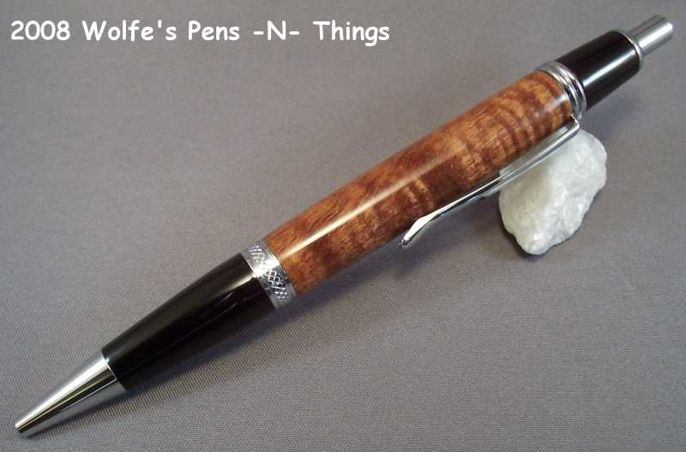
What did you like, or dislike about the blank | - Easy to turn, sand and finish. Beautiful 3-D depth and high reflectivity yields translucent effect (Curly Koa) (SG),  - liked everything, great to turn, sand and finish (GM),  - Mine had awesome curl in it (RW),
Blank needs be stabilized? | No (SG), (GM), (RW),
Wood known to be hazardous to touch or skin(your reaction only)? | No (SG), (GM), not that I know of (RW),
This wood particles or dust known be hazardous to inhale (if you know of)? | - No (SG),  - No, though I don’t recommend it.  - can be best to wear a dust mask (RW),
Tool you would not recommend to use with That will ruin the blank? (gauge, carbide cutter tool, flap sander, etc.)(your experience only) | None (SG), (GM), (RW),
Any special care for drilling? | No, easy to drill (SG), (GM), (RW),
Any special care for sanding (Dry/Wet, slow speed)? | - No (SG),  - no, but I tend to drill slowly on any wood (RW),
Finish used? | - CA/BlO (SG),  - CA, Lacquer works equally well. (GM),  - CA (RW),
Any problems when applying it? | None (SG), (GM),
Any problems after Blank finished (Ex.. cracks, cloudy, dull finish ...?, or during assembly | - None (SG), (GM),  - cloudy occasionally (RW),  - Please see additional note by: ed4copies (ED)
Used polishing or buffing? | Yes, enhances final appearance (SG),
Additional information you like to add  Top | - Curly Koa has a range of intensity of the curl figure. It is well worth the small extra effort/price to get the really top quality curl. Non-curly Koa, although rich in color and grain, does not come close to the visual appeal of the curly when used in a pen. (SG),  - Plain is rather bland to me but curly is one of the most stunning blanks there is. (GM),  - Curly Koa has awesome curl in it and is one of my favorites to turn (RW),  - I would agree with all the above. I also would add that it is a good idea to drip thin CA in the ends after they are faced. Koa will "splinter" at the "thin nib end" rather easily; this CA treatment will help avoid that. (Before you turn, after you have faced the ends of the blank with the pen mill, put thin CA on the wood on the ends.) (ED)

Member Avatar | VampMN (VMN) 08-30-2010, 10:39 AM
Blank Name | Kingwood
Before turning | Courtesy of bitshird (BIS)
Link for a sample pen
Species of the blank | Dalbergia Cearensis
What did you like, or dislike about the blank | Like (special Characteristics):  - Beautiful coloration and prominent grain pattern  Dislike (special Characteristics);
Was the blank harvested and dried by you, or kiln dried? | dry
Does the (wood) blank need to be stabilized? | No
Is the wood known to be hazardous to touch, or skin? | Related to the rosewood family, so I would say possibly.
Are the wood particles or dust known to be hazardous to inhale? (irritant, Caustic) | Related to the rosewood family, so I would say possibly.
Did you use an alternative tool because of the nature of wood fiber to achieve a better result? (Carbide cutter tool, flap sander, etc.) ? If yes, please state | I used roughing gouge and round nose scraper
Did you use any special care for drilling? | No
Any special care for sanding (Dry/Wet, slow speed)? | No
What finish did you use? Any problems applying it? | CA
Were there any problems with the blank after it was finished, cracks, cloudy finish, dull finish ...? | No
Did you use polishing or buffing? | No
Any problems when applying it? | None needed with my CA finish
Additional information to add  Top | Comes from a fairly small tree, so it is not extremely common.

Member Avatar | Rick_G
Blank Name | Locust (crotch wood)  Picture bellow Courtesy of: Rick_G  Picture bellow Courtesy of: rjwolfe3 (RW)  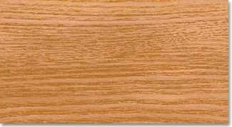 Locust, Black
Blank specie
Link for a sample pen
What did you like, or dislike about the blank | The way the light works on the grain of the blank, it doesn't really show in the photo but while the surface is smooth it looks like there are deep hills and valleys.
Blank needs be stabilized? | NO
Wood known to be hazardous to touch or skin | No
Wood particles or dust known be hazardous to inhale? | No more so than any other wood dust.
Tool you would not recommend to use with? (gauge, carbide cutter tool, flap sander, etc.)? | Skew did not seem to work well, because of the various densities of the wood more seemed to come off in some places than others. A very sharp scraper seemed to work best.
Any special care for drilling? | No it drilled easily
Any special care for sanding (Dry/Wet, slow speed)? | Sanded lightly at maximum speed.
Finish used? | CA
Any problems applying it? | No
Any problems after Blank finished (Ie. cracks,cloudy, dull finish ...? | No
Use polishing or buffing? | Automotive polishing liquid.
Additional information you like to add | This piece seemed to dull tools or was abnormally hard. Normally an initial sharpening of the scraper is enough but with this piece I had to touch it up once again. If I couldn't get a crotch wood piece I likely would not have bothered with this wood but the grain lines in this piece added an almost 3D quality to the blank I have not seen before.  Top

Member Avatar | (Please erase this line and enter your IAP handle here)
Blank Name  (A picture of the blank before you turned it or if you have another one similar to it) | Macamacuba, Maca wood  Courtesy of bitshird (BIS)
Link for a sample pen
Species of the blank
What did you like, or dislike about the blank | Like (special Characteristics):  - A  Dislike (special Characteristics);
Was the blank harvested and dried by you, or kiln dried?
Does the (wood) blank need to be stabilized?
Is the wood known to be hazardous to touch, or skin?
Are the wood particles or dust known to be hazardous to inhale? (irritant, Caustic)
Did you use an alternative tool because of the nature of wood fiber to achieve a better result? (Carbide cutter tool, flap sander, etc.) ? If yes, please state
Did you use any special care for drilling?
Any special care for sanding (Dry/Wet, slow speed)?
What finish did you use? Any problems applying it?
Were there any problems with the blank after it was finished, cracks, cloudy finish,dull finish ...?
Did you use polishing or buffing?
Additional information to add
Top

Member Avatar | DurocShark (DS) Don - A mile high
Blank Name | Mahogany (Honduras)  Picture bellow Courtesy of: rjwolfe3 (RW)
Species of the balnk | Swietenia macrophylla
What did you like, or dislike about the blank | Like: Warm coloring, chatoyance in end grain  Dislike: open pores, brittle grain.
Was the blank wet, dry, kiln dry? | Kiln dried
Does the (wood) blank need to be stabilized? | Possibly (see notes below)
Is the wood known to be hazardous to touch? | no
Are the wood particles or dust known to be hazardous to inhale? | no
Did you use the gouge? | yes
Did you use the skew? | yes
Did you use an alternative tool? (carbide cutter tool, flap sander, etc.) ? If Yes, please sate | no
Did you use any special care for drilling? | no
Is the blank hard to sand? | no
What finish did you use? Any problems applying it? | I've used everything on mahogany. CA for pens, lacquer, poly, shellac etc for flatwork
Were there any problems with the blank after it was finished , cracks,cloudy finish,dull finish ...? | no
Did you use polishing or buffing? | I always buff or polish my finishes. Burnishing applied to bare wood.
Additional information to add | Mahogany makes for boring pens in the long grain. Easy to turn, much like oak, but needs sharp tools to avoid tear out. End grain (cross cut) blanks make stunning pens. The chatoyance of the end grain looks much like leopard fur. Super sharp tools, thin CA stabilization, are required to prevent blowouts and out of round in end grain blanks.  Top

Member Avatar | - rjwolfe3 (RW) 8/28/10 8:10 AM  - penmanship (PM) ) 8/28/10 08:36 AM
Blank Name) | Ambrosia (sugar)Maple
Blank picture before turning | courtesy of: rjwolfe3 (RW)
Link for a sample pen | 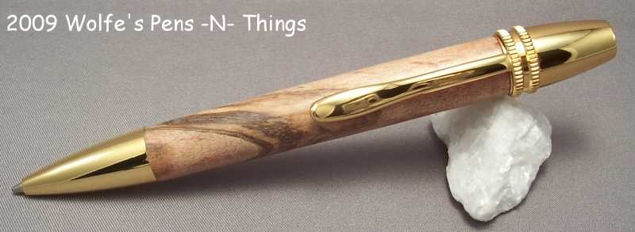  Courtesy of: rjwolfe3 (RW)  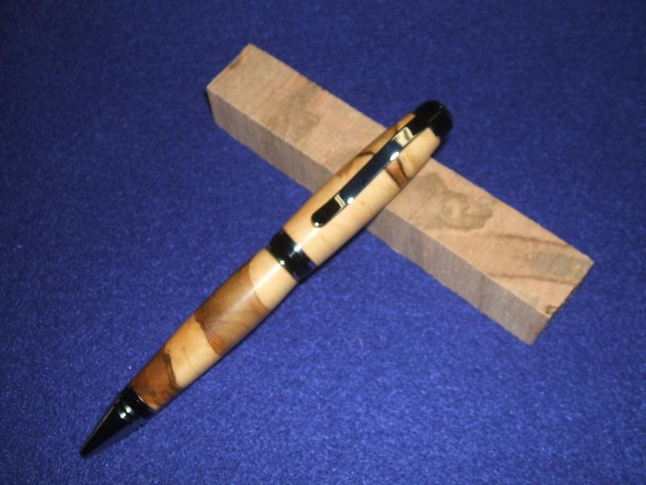 courtesy of: penmanship (PM)
Species of the blank | Ambrosia Maple
What did you like, or dislike about the blank | Like :  - The colors are awesome(RW)  - easy to turn (PM)  Dislike -  - Can have some soft spots (RW)  - easy to have a blow out (PM)
Was the blank harvested and dried by you, or kiln dried? | - Not sure - can't remember (RW)  - dried (PM)
Does the (wood) blank need to be stabilized? | - Sometimes it makes it easier to turn (RW)  - I prefer not whenever possible (PM)
Is the wood known to be hazardous to touch, or skin? | - No (RW)  - not to me (PM)
Are the wood particles or dust known to be hazardous to inhale? (irritant, Caustic) | - yes - use DC and/or mask (RW)  - Not to me, but it can't be good to inhale anything being turned..... (PM)
Did you use an alternative tool because of the nature of wood fiber to achieve a better result? (Carbide cutter tool, flap sander, etc.) ? If yes, please state | - Can be turned with regular tools but Carbide makes everything easy! (RW)  - nope...gouge & skew (PM)
Did you use any special care for drilling? | - no(RW)  - Near the end of the drilling don't rush the bit through. Some blanks really blow out (PM)
Any special care for sanding (Dry/Wet, slow speed)? | - not really (RW)  - I usually slow the speed down for sanding & polishing. Too fast, and these really heat up. (PM)
What finish did you use? Any problems applying it? | - CA - no problems (RW)  - W.O.P - 6 coats - simple pimple...... (PM)
Were there any problems with the blank after it was finished, cracks, cloudy finish,dull finish ...? | None (PM)
Did you use polishing or buffing? | - polished the CA finish (RW)  - Polished the W.O.P the next day with dry MM, then HUT Plastic Polish to knock the shine home! (PM)
Additional information to add  Top | Sometimes wood can have soft spots and holes. May need thin CA for the soft spots and med/thick for the holes. Makes a very nice pen. (RW)

Member Avatar | Hucifer (HU) 8/24/10 07:58 PM
Blank Name  Top | Birdseye Maple  The first pic is the log, the second is a close up of the eyes in the raw, and the third is a blank that came from the cut close to the bark.  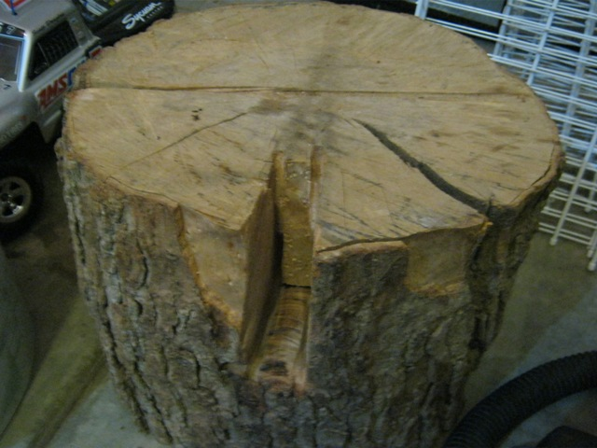  Pic. Of the blank before turned  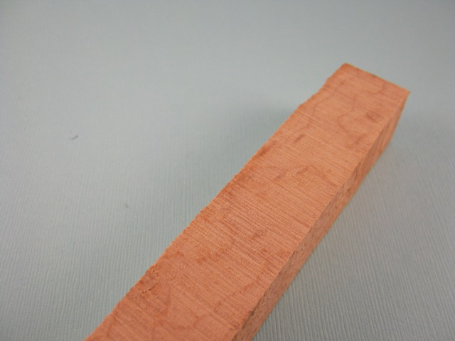  Curley maple  Courtesy of rjwolfe3  Quilted maple  Courtesy of rjwolfe3
Link for a sample pen | 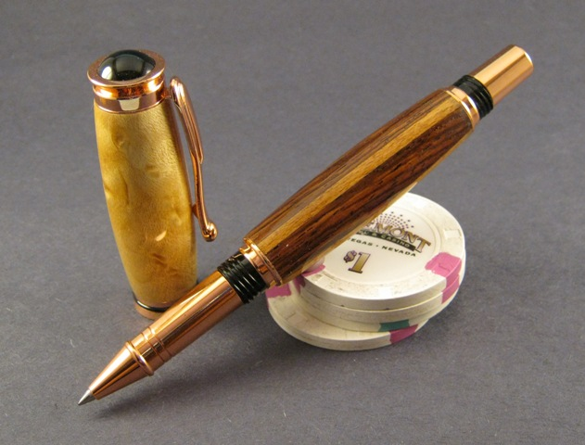
Species of the blank | Birdseye is not a species, but a "mysterious" characteristic found in some hard maple found in both Canada and the US
What did you like, or dislike about the blank | - Like: figure, ease of turning, color, eyes.  - Dislike: nothing
Was the blank harvested and dried by you, or kiln dried? | Harvested by me from a 18" dia. log cut in eastern Canada in the 80's.
Does the (wood) blank need to be stabilized? | No
Is the wood known to be hazardous to touch, or skin? | No
Are the wood particles or dust known to be hazardous to inhale? (irritant, Caustic) | No. That is to say no worse than any fine dust...
Did you use an alternative tool because of the nature of wood fiber to achieve a better result? (Carbide cutter tool, flap sander, etc.) ? If yes, please state | No
Did you use any special care for drilling? | No
Any special care for sanding (Dry/Wet, slow speed)? | No
What finish did you use? Any problems applying it? | Finished with my standard teak oil, then 6 coats of CA, then micromesh to 12000, and plastic polish.
Were there any problems with the blank after it was finished, cracks, cloudy finish,dull finish ...? | Nothing, it was beautiful.
Did you use polishing or buffing? | Plastic polish
Additional information to add | This was the first blank I have pulled from this log, and I was pleasantly surprised at how easily it turned.

Member Avatar | MatthewZS (MZS) 8-23-10 , 03:38 PM
Blank Name | Spalted Maple  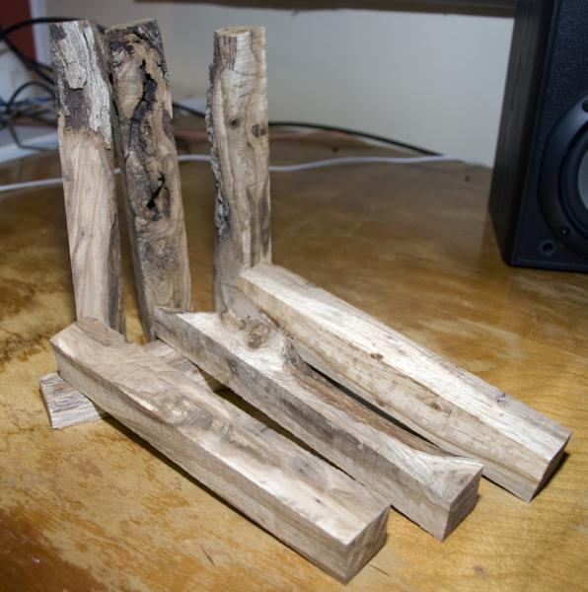
Link for a sample pen | http://www.penturners.org/forum/atta...1&d=1281498131  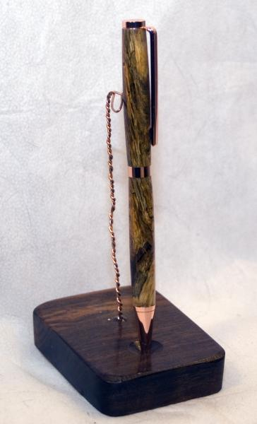
Species of the blank | Maple
What did you like, or dislike about the blank | Like: Easy to turn, fairly stable  Dislike: wood gets spongy quickly with little age if exposed to the elements, turning can be rewarding but tricky.
Was the blank harvested and dried by you, or kiln dried? | Harvested yes, dried yes, kiln no.
Does the (wood) blank need to be stabilized? | When it gets spongy and aged yes, but it can be worth it.
Is the wood known to be hazardous to touch, or skin? | No
Are the wood particles or dust known to be hazardous to inhale? (irritant, Caustic) | Can build up sensitivity overtime to both dust and the wood. See this page for more info http://www.mimf.com/archives/toxic.htm
Did you use an alternative tool because of the nature of wood fiber to achieve a better result? (Carbide cutter tool, flap sander, etc.) ? If yes, please state | The softer spongier of the blanks I turned even after stabilizing, I didn't turn down the last few mm instead I used 220 grit sand paper. The harder more stable blanks I had turned like a dream with all my old favorite tools.
Did you use any special care for drilling? | Just the care I take with any drilling.
Any special care for sanding (Dry/Wet, slow speed)? | None
What finish did you use? Any problems applying it? | CA and MM, no problems.
Were there any problems with the blank after it was finished, cracks, cloudy finish,dull finish ...? | None.
Did you use polishing or buffing? | None.
Additional information to add  Top | None of the blanks pictured went into the pen pictured. All the wood came from branches only 3-5 inches around. The spalting ranged from light to VERY pronounce along the length of the branch. The blanks pictured here are on the lighter end of the scale. The pen pictured was an example of the softer wood/more pronounced spalting end of the spectrum. I should also point out that while the blanks pictured here do show some of the spalting without cutting into them, they are by no means the best examples. The better examples I had are already pens.

Member Avatar | (Please erase this line and enter your IAP handle here)
Blank Name | Marbel wood  Courtesy of bitshird (BIS)
Link for a sample pen
Species of the blank
What did you like, or dislike about the blank | Like (special Characteristics):  - A  Dislike (special Characteristics);
Was the blank harvested and dried by you, or kiln dried?
Does the (wood) blank need to be stabilized?
Is the wood known to be hazardous to touch, or skin?
Are the wood particles or dust known to be hazardous to inhale? (irritant, Caustic)
Did you use an alternative tool because of the nature of wood fiber to achieve a better result? (Carbide cutter tool, flap sander, etc.) ? If yes, please state
Did you use any special care for drilling?
Any special care for sanding (Dry/Wet, slow speed)?
What finish did you use? Any problems applying it?
Were there any problems with the blank after it was finished, cracks, cloudy finish,dull finish ...?
Did you use polishing or buffing?
Additional information to add
Top

Member Avatar | ?????
Blank Name | Mulberry
Species of the blank | Morus rubra
What did you like, or dislike about the blank | Like: Nice dense grain, reddish brown in color  Dislike: Boring grain
Was the blank wet, dry, kiln dry? | Dried to about 8%, this was from a chunk of firewood given to me that had been cut for ~35 years.
Does the (wood) blank need to be stabilized? | No
Is the wood known to be hazardous to touch? | No
Are the wood particles or dust known to be hazardous to inhale? | Not to my knowledge
Did you use the gouge? | No
Did you use the skew? | Yes
Did you use an alternative tool? (carbide cutter tool, flap sander, etc.) ? If Yes, please sate | Homemade carbide cutter
Did you use any special care for drilling? | Drill slow and clear chips frequently. On Bias and Cross cut blanks, I cut them  1/4” long and don't drill through, then cut to length.
Is the blank hard to sand? | No
What finish did you use? Any problems applying it? | Friction Polish or CA. I tried some stains to excite the boring grain.
Were there any problems with the blank after it was finished , cracks,cloudy finish,dull finish ...? | No
Did you use polishing or buffing? | RenWax
Additional information to add
Top

- N

- N

Blank picture Before turning
Blank picture After turning or rounding it off
Link to or picture of a sample pen

Member Avatar | - hilltopper46 (HT) 08-09-2010, 09:47 AM  - KenV (KV) 08-09-2010, 10:40 AM  - Hucifer (HU) 08-09-2010, 10:47 AM  - Mickey (MIK) 08-09-2010, 12:41 PM  - louisbry (LB) 09-12-2010, 01:00 PM
Blank Name | Osage Orange (Bois D'arc, Bodarc, Bowdarc, Hedge, Hedgeapple) (HT)
Blank picture Before turning | 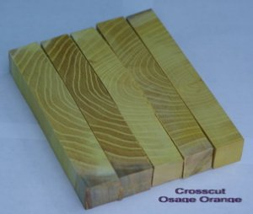 Courtesy of: louisbry (LB)
Blank picture After turning or rounding it off
Link to or picture of a sample pen | 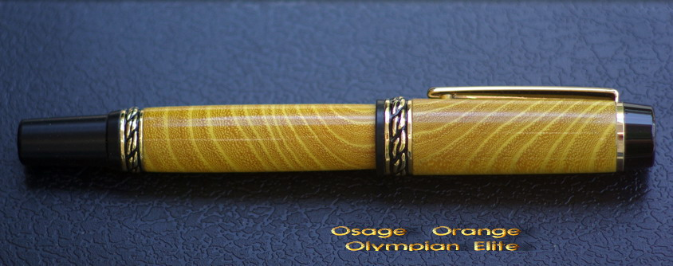  Courtesy of: louisbry (LB)
Species of the blank | Maclura pomifera
What did you like, or dislike about the blank | Like:  - Nice golden yellow color - prominent grain structure, hard wood that polishes fairly well. Can have rose or pink colored striations. (HT)  - Nice vivid yellow color and grain pattern, a very hard wood  - I have had one piece of green Osage Orange -- turned easy (KV)  - Shades will differ from tree to tree (HU)  Dislike:  - Wood is very hard - can split during assembly if care is not taken. Wood will darken to a medium brown after exposure to light. (HT)  - It is one of the densest woods in North America. MOF I don't believe it will float. It will start out a nice yellow or orange and within a matter of days exposed to light and air it will begin to turn to a brown. The grain is tight and brittle. The grain is nothing to brag about except for the nice color (which it loses quickly). It also tends to dull tools fairly quickly. (MIK)
Was the blank wet, dry, kiln dry? | - Dried to about 8%  - I dried it (HT)
Does the (wood) blank need to be stabilized? | No (HT)
Is the wood known to be hazardous to touch? | No (HT)
Are the wood particles or dust known to be hazardous to inhale? | - No, but the dust has a bit of an offensive order.  - No (HT)
Did you use an alternative tool? (Carbide cutter tool, flap sander, etc.) ? If Yes, please state | - (Gauge, Skew) Yes, and also Homemade carbide cutter.  - (HT)
Did you use any special care for drilling? | - Drill slow and clear chips frequently. On Bias and Cross cut blanks, I cut them1/4” long and don't drill through, then cut to length.  - No (HT)
Is the blank hard to sand? | - No , (HT)  - It is hard to sand simply because it is so dense. (MIK)
What finish did you use? Any problems applying it? | - Friction Polish or CA  - CA (HT)
Were there any problems with the blank after it was finished, cracks, cloudy finish,dull finish ...? | - None  - See above (HT)
Did you use polishing or buffing? | RenWax
Additional information to add  Top | - ……..  - Wood has a high silica content that quickly dulls tooling (HT)  - Dry -- best term I have heard "turns like a brick" This is one of the woods that works better (in my opinion) with carbide inserts than with HSS tools. Polishes to a very nice finish. In spite of the difficulty of cutting, the outcome makes this a good wood for turning (KV)  - found mainly in TX and OK I believe. I have made some bottle stoppers from it and didn't really notice anything out of the ordinary when turning (HU)  - I have used it a great deal for other things.. It is highly photo-reactive.. This may be slowed a little with the right finish. Long clear boards are hard to find. The wood will have knots and the limbs tend to twist and curve. This tree was planted through the southwest during the dust bowl era to help control erosion. (MIK)

Member Avatar | DurocShark (DS) Don - A mile high
Blank Name | Padauk Picture bellow Courtesy of: rjwolfe3 (RW)  Padauk, Tiger Striped  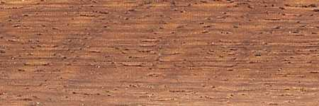
Species of the balnk | Pterocarpus soyauxi
What did you like, or dislike about the blank | Like: Deep rust color, chatoyance  Dislike:
Was the blank wet, dry, kiln dry? | Generally it's kiln dried
Does the (wood) blank need to be stabilized? | no
Is the wood known to be hazardous to touch? | no
Are the wood particles or dust known to be hazardous to inhale? | Not generally, but any tropical wood can trigger allergic reactions
Did you use the gouge? | Yes
Did you use the skew? | yes
Did you use an alternative tool? (carbide cutter tool, flap sander, etc.) ? If Yes, please sate | no
Did you use any special care for drilling? | No more than usual
Is the blank hard to sand? | no
What finish did you use? Any problems applying it? | I've used shellac, lacquer, and of course CA for Padauk. No problems with any of them.
Were there any problems with the blank after it was finished , cracks,cloudy finish,dull finish ...?
Did you use polishing or buffing? | I always polish or buff my finish. Burnishing is applied to the bare wood.
Additional information to add  Top | African Padauk is the Padauk we normally see in the hobby, though there are a few other trees that can be called Padauk. Smells a bit like a sweet cigar when machined. Bright rust/orange coloring darkens to very deep rust over time. Segmented blanks containing Padauk require care as the dust can contaminate the other woods. Thin CA stabilization in segmented blanks can minimize this problem.

Member Avatar | - Alexanderpens (AP) 09-08-2010, 01:30 PM  - JimMc7 (JMC) 09-11-2010, 04:22 PM
Blank Name | Pink ivory
Blank picture Before turning | courtesy of : JimMc7 (JMC)
Blank picture After turning or rounding it off
Link to or picture of a sample pen | 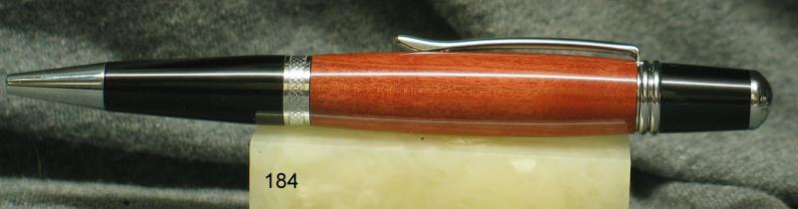 courtesy of : JimMc7 (JMC)  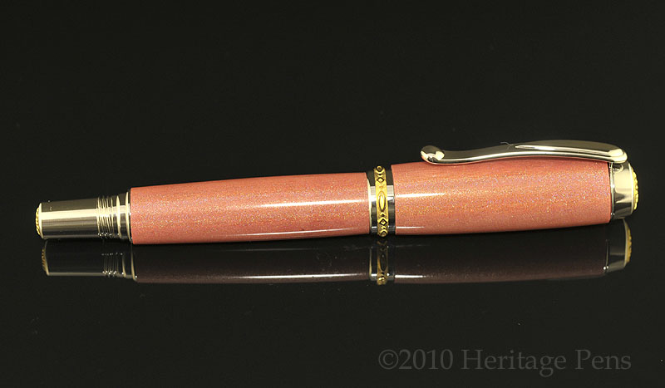  Courtesy of: DCBluesman
Species of the blank
What did you like, or dislike about the blank | Like  - A hard wood(AP), (JMC)  - Polishes very well. (JMC)  Dislike  - Difficult for me to drill. Might just be my drill press (AP), (JMC)  - Blanks have inconsistent color in my experience (see notes bellow)
Was the blank harvested and dried by you, or kiln dried? | Dry(AP), (JMC)
Does the (wood) blank need to be stabilized? | No(AP), (JMC)
Is the wood known to be hazardous to touch, or skin? | Allergen spec(AP), (JMC)
Are the wood particles or dust known to be hazardous to inhale? (irritant, Caustic) | Allergen spec (AP), (JMC)
Did you use an alternative tool because of the nature of wood fiber to achieve The best result? (Carbide cutter tool, flap sander, etc.) ? If yes, please state | No, used gouge to rough shape, Finished with skew (AP), (JMC)
Did you use any special care for drilling? | Drill slow and clear chips frequently (AP),
Any special care for sanding (Dry/Wet, slow speed)? | Moderately (AP) (JMC)
What finish did you use? Any problems applying it? | Minwax, Friction Polish, or CA, all work well, no problem in applying it. (AP), (JMC)
Any problems after Blank finished such as (cracks, cloudy finish, dull finish, etc.? Or, during assembly? | - None (AP)  - I did have one crack a month of so after completion. I've done ~15 pink ivory pens and, to date, this is the only one that cracked (JMC)  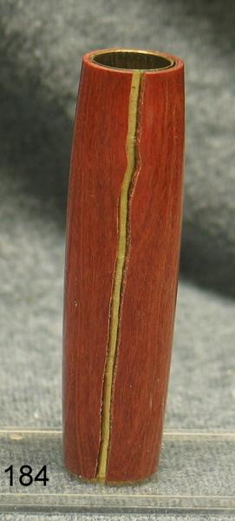 courtesy of : JimMc7 (JMC)
Did you use polishing or buffing? | - RenWax (AP),  - Blanks have inconsistent color in my experience -- ~50% have very nice pink/rose color, but the rest are a dull brown -- usually easy to determine from the start so you don't have to wait until completion to see if you're turning a clunker (unlike Bakelite!). I've only purchased sight unseen from Lee Valley and Woodcraft so hopefully better ratio of good to bad from others! (JMC)
Additional information to add  Top | Pretty and rare, will stand out on larger kits. (AP), (JMC)

Member Avatar | snyiper (sny) 8- 23, 2010 7:15 AM
Blank Name | Pistachio
Blank specie | Pistacia vera L., Anacardiaceae
Link to a sample pen
What did you like, or dislike about the blank | It was ok kind of bland tight wood.
Blank needs be stabilized? | no
Wood known to be hazardous to touch or skin? | no
Wood particles or dust known be hazardous to inhale? | All are
Tool you would recommend to use with? (Gauge, carbide cutter tool, flap sander, etc.) | Used carbide and skew
Any special care for drilling? | slow and clear
Any special care for sanding (Dry/Wet, slow speed)? | no
Finish used? | BLO/CA
Any problems when applying it? | splotchy may have been user error not wood
Any problems after Blank finished (ex. cracks,cloudy, dull finish ...?, or during assembly | no
Used polishing or buffing? Polish with rubbing compound polish with Never dull
Additional information you like to add  Top | Not a very interesting piece I turned finishes nice.

Member Avatar | - bradh - aka HardingPens, (BR)  - Alexanderpens (AP), 08-13-2010, 04:14 AM  - Blue Danube (BD) 08-09-2010, 10:38 AM  - Arioux (AR), 08-09-2010, 10:42 AM ok
Blank Name | Purpleheart Picture bellow Courtesy of :bradh - (BR)  Picture bellow Courtesy of: rjwolfe3 (RW)
Species of the balnk | - Peltogyne spp. (BR)  - Amaranth (BD)
What did you like, or dislike about the blank | Like:  - The purple colour is beautiful at its peak. Even the faded colour is a beautiful purple tinged brown. (BR)  - The deep color with time. Easy to work with. (AP),  - its dense  - Nice color (AR),  Dislike:  - The brilliant purple colour only comes on after exposure to heat to sunlight. The colour eventually fades to brown with age. (BR)  - Wood heating when sanding and drilling. See bellow under sanding and drilling. (AP),  - can "burn" when cutting
Was the blank wet, dry, kiln dry? | - The brilliant purple colour only comes on after exposure to heat to sunlight. The colour eventually fades to brown with age. (BR)  - Dry (AP), (AR),
Does the (wood) blank need to be stabilized? | - No (BR), (AR),  - Not a clue (AP),
Is the wood known to be hazardous to touch? (gives rashes or hives) | - no (BR), (AR),  - Not unless allergic (AP),
Are the wood particles or dust known to be hazardous to inhale? (irritant, caustic) | - no (BR)  - Not to my knowledge. I've gone without a mask a couple of times and did fine (AP),  - As far a irritant, all woods and dust are problems. Use dust collection system as close to lathe as possible. Some people react, some do not ever have a problem (BD)  - Some people might get minor skin or nasal irritation from the dust (AR),
Did you use the gouge, skew? | - Yes, both (BR)  - No (AR),
Did you use an alternative tool? (carbide cutter tool, flap sander, etc.) ? If Yes, please sate | - no(AR),  - can "burn" when cutting if you do not use sharp tools (BD)
Did you use any special care for drilling? | - no (BR)  - Careful when drilling. Wood heats easy and will crack under a drill. (AP),  - No. Will need pre-drill if you want to use screw with it(AR),
Is the blank hard to sand? | - No (BR)  - Careful when sanding. Wood heats easy and will discolor/darken with sandpaper. If you use a fresh piece of paper each time, you'll be fine. (Or mesh sanders. Don't know how well they work yet.). Time consuming (AP),  - It’s dense and can "burn" when cutting if you do not use sharp tools. (BD)  - Sand easily (AR),
What finish did you use? Any problems applying it? | - CA or CA/BLO are easy to apply, no special care needed. An easy wood to finish. (BR)  - In order; walnut oil for cleaning dirt off, friction lacquer polish, ca glue finish, and renaissance wax for shine (AP),  - Finishes very well but may darken over time. (BD)  - Ca, lacquer. Open grain that will splinter a lot, sand dust might stick in the grooves. (AR),
Were there any problems with the blank after it was finished, cracks,cloudy finish,dull finish ...? | - no (BR)  - Nothing really. (AP),  - Finishes very well but may darken over time (BD)  - Might turn brown after time, will be back purple when expose to sun. A vinager treatment will keep it purple too
Did you use polishing or buffing? | - I always MM to 12000 then buff my finishes for high gloss. (BR)  - no (AR),
Additional information to add | - A beautiful coloured wood, but the colour fades to brown with age. The colour is not present after turning, a few hours in the sun or in heat will bring on the colour. Too much heat or light will return the colour to a purple-brown tone. (BR)  - Great seller, if your blanks are brownish instead of purple, Turn them but don't finish them. Get down to that final sanding layer and let them sit for a couple of days in a sunny area. They should turn to a rich purple. Works for me anyway. Could be the Houston heat. (AP),  - As far a irritant, all woods and dust are problems. Use dust collection system as close to lathe as possible. Some people react, some do not ever have a problem.  Dust collection, eye protection, and a decent cartridge type mask should be used for any woodworking.  Have fun purpleheart makes beautiful projects. (BD)  - Watch for burning while milling as it is pretty easy to burn if your cutter is dull or you're going too slow. Burn marks are very difficult to remove from purpleheart. (AR),  __________________  Top

- N

Member Avatar | Snyiper (Sny) Glenn
Blank Name | Red Cedar (Eastern)  Picture bellow Courtesy of: rjwolfe3 (RW)
Species of the blank | Juniperus virginiana, (sny)
What did you like, or dislike about the blank | Like: Very easy to turn, smells great, easy on tools and turns fast. , (sny)  Dislike: Very soft even after CA finish, most heart wood is very boring, (sny)
Was the blank wet, dry, kiln dry? | Naturally dried I harvested the tree, (sny)
Does the (wood) blank need to be stabilized? | It may firm up the softness of the wood but not needed, , (sny)
Is the wood known to be hazardous to touch? | Not to my knowledge, (sny)
Are the wood particles or dust known to be hazardous to inhale? | I would have to say Cedar is very aromatic and dust should not be inhaled, (sny)
Did you use the gouge? | Yes, (sny)
Did you use the skew? | Yes, (sny)
Did you use an alternative tool? (carbide cutter tool, flap sander, etc.) ? If Yes, please sate | Yes, Home made carbide tool, (sny)
Did you use any special care for drilling? | Easy to drill wood is soft, (sny)
Is the blank hard to sand? | very easy with coarser grits, (sny)
What finish did you use? | CA-CA/BLO-Plexitone used all three one time or another, (sny)
Any problems applying it? | Took all well, (sny)
Were there any problems with the blank after it was finished , cracks, cloudy finish, dull finish ...? | soft tends to dent if handled rough or dropped. , (sny)
Did you use polishing or buffing? | polish on the lathe with Mothers mag wheel polish. , (sny)
Additional information to add | Top

Member Avatar | bradh , diver123 (DIV),
Blank Name | Red heart Picture bellow Courtesy of :bradh - (BR)  Picture bellow Courtesy of: rjwolfe3 (RW)  
Species of the balnk | Erythroxylon spp. (BR),
What did you like, or dislike about the blank | Like: (special Characteristics)  Has a nice color to it finishes well, A popular wood with customers.  (DIV),  Dislike: (special Characteristics)  The grain is often plain with little figure. The colour will fade to more brownish with age. Like, The colour is often a vibrant red to red-brown at the beginning.  checking see below for details.
Was the blank wet, dry, kiln dry? | Kiln dried, wet (DIV),
Does the (wood) blank need to be stabilized? | No (DIV),
Is the wood known to be hazardous to touch? | no , /not that I am aware of. (DIV),
Are the wood particles or dust known to be hazardous to inhale? | No, /not that I am aware of. (DIV),
Did you use the gouge? | yes (BR), (BR),
Did you use the skew? | Yes(BR), (BR),
Did you use an alternative tool? (carbide cutter tool, flap sander, etc.) ? If Yes, please sate | No, (BR),
Did you use any special care for drilling? | No (DIV),
Is the blank hard to sand? | No (DIV),
What finish did you use? Any problems applying it? | Any problems applying it? CA or CA/BLO, this wood is easy to finish well.  friction polish shellac and walnut oil
Were there any problems with the blank after it was finished , cracks,cloudy finish,dull finish ...? | No (DIV),
Did you use polishing or buffing? | I always MM to 12000 then buff my finishes for high gloss.  No, (DIV),
Additional information to add | This wood looks and works like a red version of maple, similar hardness and grain patterns. A popular colour with customers, both men and women. (BR),  I first turned a peice while it still had some moisture in it that wasnt detectable by touch really and it checked on me while sanding. After letting pieces dry for 6 months and turning another it was very easy and sanded well with out any further problems. hope this helps(DIV),
Top

Member Avatar | (Please erase this line and enter your IAP handle here)
Blank Name  (A picture of the blank before you turned it or if you have another one similar to it) | Red Mallee Burl  Courtesy of bitshird (BIS)
Link for a sample pen
Species of the blank
What did you like, or dislike about the blank | Like (special Characteristics):  - A  Dislike (special Characteristics);
Was the blank harvested and dried by you, or kiln dried?
Does the (wood) blank need to be stabilized?
Is the wood known to be hazardous to touch, or skin?
Are the wood particles or dust known to be hazardous to inhale? (irritant, Caustic)
Did you use an alternative tool because of the nature of wood fiber to achieve a better result? (Carbide cutter tool, flap sander, etc.) ? If yes, please state
Did you use any special care for drilling?
Any special care for sanding (Dry/Wet, slow speed)?
What finish did you use? Any problems applying it?
Were there any problems with the blank after it was finished, cracks, cloudy finish,dull finish ...?
Did you use polishing or buffing?
Additional information to add
Top

Member Avatar | bradh - aka HardingPens
Blank Name | Red Oak
Species of the balnk | Oak> Quercus spp. ; Red Oak Group> Erythrobalanus; Main N.A. commercial species> Quercus coccinea , Quercus falcata , Quercus kelloggii, Quercus laurifolia, Quercus nigra, Quercus nuttallii, Quercus palustris Quercus palustris Quercus palustris, Quercus phellos, Quercus rubra, Quercus shumardii, Quercus velutina, and others.
What did you like, or dislike about the blank | Like> Good contrast in grain colours, the wood is easy to find and inexpensive.  Dislike> Open grain wood is difficult to get smooth.
Was the blank wet, dry, kiln dry? | Kiln dried
Does the (wood) blank need to be stabilized? | No
Is the wood known to be hazardous to touch? | no
Are the wood particles or dust known to be hazardous to inhale? | no
Did you use the gouge? | yes
Did you use the skew? | yes
Did you use an alternative tool? (carbide cutter tool, flap sander, etc.) ? If Yes, please sate | no
Did you use any special care for drilling? | no
Is the blank hard to sand? | No. The pores of the wood need to be cleared or sanding grit will lodge there.
What finish did you use? Any problems applying it? | Any problems applying it? CA, CA/BLO or Poly. Best to wet sand with CA first to fill the pores.
Were there any problems with the blank after it was finished , cracks,cloudy finish,dull finish ...? | I often have to add additional finish layers to fill the pores.
Did you use polishing or buffing? | I always MM to 12000 then buff my finishes for high gloss.
Additional information to add  Top | A common NA wood and easy to work with. There are many different types of Red Oak, but they perform similarly in woodworking.

Member Avatar | - ed4copies (ED),  - MrPukaShell (MPS)
Blank Name | Red Palm
Species of the blank
Link for a sample pen | http://www.penturners.org/photos/ima.../1_redpalm.jpg  austing458 8/24/10  (Cross cut Red Palm on a "Click" Wall Street II) MrPukaShell 8/24/10  http://www.penturners.org/forum/showthread.php?t=66757  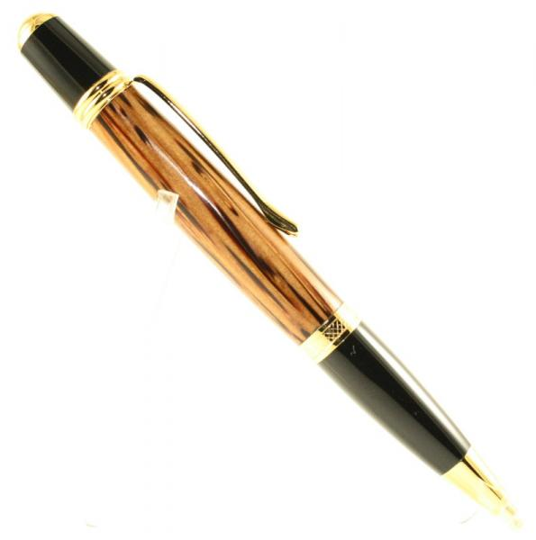 courtesy of mbroberg
What did you like, or dislike about the blank | - Like The pens are GREAT  - Dislike Not the easiest grain to turn
Was the blank harvested and dried by you, or kiln dried? | - I suspect it was air dried, but it was very dry when turned.  - would be helpful (MPS)
Does the (wood) blank need to be stabilized? | I don't think so.
Is the wood known to be hazardous to touch, or skin? | Splinters very easily--but I did not have a reaction to the implanted splinters.
Are the wood particles or dust known to be hazardous to inhale? (irritant, Caustic) | Not that I know of.
Did you use an alternative tool because of the nature of wood fiber to achieve a better result? (Carbide cutter tool, flap sander, etc.) ? If yes, please state | No
Did you use any special care for drilling? | No
Any special care for sanding (Dry/Wet, slow speed)? | - You may go to a lower grit than normal to overcome the deep grain--similar to red oak or wenge--whatever you may be familiar with.  - none taken
What finish did you use? Any problems applying it? | - simple friction polish. no problems, but today I would use CA finish  - CA Finish and no problems
Were there any problems with the blank after it was finished, cracks, cloudy finish,dull finish ...? | - Just the deep grain already mentioned.  - None
Did you use polishing or buffing? | NO
Additional information to add  Top | I would suggest starting at 150 grit, then progressing roughly as follows: 240, 320, 400, 600. Then working a CA finish. This would "flatten" the grain and produce a shine, over which the CA should provide a nice final product.

Member Avatar
Blank Name | Rosewood (East Indian)
Species of the balnk | Dalbergia Latifolia or Dalbergia Mindenaensis
What did you like, or dislike about the blank | I liked everything about it. The heart wood was dark, reddish; the sapwood was tan and speckled; a black, 1/8" line separated the heart from the sap, completely around the blank.
Was the blank wet, dry, kiln dry? | Dry
Does the (wood) blank need to be stabilized? | No
Is the wood known to be hazardous to touch? | No
Are the wood particles or dust known to be hazardous to inhale? | Yes
Did you use the gouge? | Yes
Did you use the skew? | No
Did you use an alternative tool? (carbide cutter tool, flap sander, etc.) ? If Yes, please sate | Oland Tool, Scraper
Did you use any special care for drilling? | No
Is the blank hard to sand? | Sands well, dry, and wet.
What finish did you use? Any problems applying it? | Pre-catalyzed Lacquer, Sprayed
Were there any problems with the blank after it was finished , cracks,cloudy finish,dull finish ...? | None.
Did you use polishing or buffing? | After lacquer cured. Tripoli, White Diamond, Clean Wheel
Additional information to add  Top | I turned the piece the day I got it from a friend. The next day, he received an email from the person he got it from, telling that the dust was toxic. I got a sinus and lung infection that lasted about 3 months. It's gorgeous wood, and I would turn it again.

Blank Name | Honduran Rosewood
please provide a pic. of the blank before and after turning and would like to share, would be greatly appreciated. (If I get mine first and turn it I'll post mine). Provide a link to your pen also.
http | //www.penturners.org/forum/attachment.php?attachmentid=27869&d=1270591989
Species of the blank | Dalbergia stevensonii
What did you like, or dislike about the blank
Like (special Characteristics) | Awesome grain, the burl wood has a chatoyance to it and is a very appealing color.
Dislike (special Characteristics) | None.
Was the blank harvested and dried by you, or kiln dried? | Not by me.
Blank needs be stabilized? | Nope.
Wood known to be hazardous to touch or skin? | Not really.
Wood particles or dust known be hazardous to inhale? (irritant, Caustic) | Some can be allergic as with most rosewoods.
Did you use an alternative tool because of the nature of wood fiber to achieve a better result? (Carbide cutter tool, flap sander, etc.) ? If yes, please state | No.
Any special care for drilling? | Drill slow, keep it cool.
Any special care for sanding (Dry/Wet, slow speed)? | Dry sand, sand lengthwise. Scratches show easy.
What finish did you use? Any problems applying it? | CA
Were there any problems with the blank after it was finished, cracks, cloudy, and dull finish ...? | No.
Did you use polishing or buffing? | On lathe with a soft towel.
Additional information you like to add  Top | In my opinion, a beautiful wood. Maybe the most beautiful. Watch out for checks in the wood. Make sure your tool is very very sharp!
__________________

Member Avatar | - JBCustomPens (JBC)  - phillywood (PW)
Blank Name | Rosewood (Honduran) Picture bellow Courtesy of: phillywood (PW)  Picture bellow Courtesy of: rjwolfe3 (RW)
link for a sample pen | http://www.penturners.org/photos/ima...HRB_above2.JPG (JBC)
Species of the blank | Dalbergia stevensonii (JBC)
What did you like, or dislike about the blank | Like (special Characteristics):  - Awesome grain, the burl wood has a chatoyance to it and is a very appealing color. (JBC)  Dislike (special Characteristics);  - None. (JBC)
Was the blank harvested and dried by you, or kiln dried? | Not by me. (JBC)
Blank needs be stabilized? | Nope. (JBC)
Wood known to be hazardous to touch or skin? | Not really. (JBC)
Wood particles or dust known be hazardous to inhale? (irritant, Caustic) | Some can be allergic as with most rosewoods. (JBC)
Did you use an alternative tool because of the nature of wood fiber to achieve a better result? (Carbide cutter tool, flap sander, etc.) ? If yes, please state | No. (JBC)
Any special care for drilling? | Drill slow, keep it cool. (JBC)
Any special care for sanding (Dry/Wet, slow speed)? | Dry sand, sand lengthwise. Scratches show easy. (JBC)
What finish did you use? Any problems applying it? | CA(JBC)
Were there any problems with the blank after it was finished, cracks, cloudy, and dull finish ...? | No. (JBC)
Did you use polishing or buffing? | On lathe with a soft towel. (JBC)
Additional information you like to add  Top | In my opinion, a beautiful wood. Maybe the most beautiful. Watch out for checks in the wood. Make sure your tool is very sharp! (JBC)
- N

Member Avatar
Blank Name | Sassafras
Species of the blank | Sassafras albidum
What did you like, or dislike about the blank | Like: Easy to cut turn and sand, nice aroma while turning and sanding.  Dislike: None
Was the blank wet, dry, kiln dry? | Dried to 8% in food dehydrater
Does the (wood) blank need to be stabilized? | Moderately hard wood, No.
Is the wood known to be hazardous to touch? | No
Are the wood particles or dust known to be hazardous to inhale? | No
Did you use the gouge? | Used a gouge sometimes to rough turn
Did you use the skew? | Generally I use the skew
Did you use an alternative tool? (carbide cutter tool, flap sander, etc.) ? If Yes, please sate | No
Did you use any special care for drilling? | Drill slow and clear chips frequently. On Bias and Cross cut blanks, I cut them  1/4” long and don't drill through, then cut to length.
Is the blank hard to sand? | No
What finish did you use? Any problems applying it? | Friction Polish or CA, sometimes stail to bring out the grain first.
Were there any problems with the blank after it was finished , cracks,cloudy finish,dull finish ...? | No
Did you use polishing or buffing? | RenWax
Additional information to add
Top

Member Avatar | (Please erase this line and enter your IAP handle here)
Blank Name  (A picture of the blank before you turned it or if you have another one similar to it) | Tiete Rosewood, Amazon Rosewood  Courtesy of bitshird (BIS)
Link for a sample pen
Species of the blank
What did you like, or dislike about the blank | Like (special Characteristics):  - A  Dislike (special Characteristics);
Was the blank harvested and dried by you, or kiln dried?
Does the (wood) blank need to be stabilized?
Is the wood known to be hazardous to touch, or skin?
Are the wood particles or dust known to be hazardous to inhale? (irritant, Caustic)
Did you use an alternative tool because of the nature of wood fiber to achieve a better result? (Carbide cutter tool, flap sander, etc.) ? If yes, please state
Did you use any special care for drilling?
Any special care for sanding (Dry/Wet, slow speed)?
What finish did you use? Any problems applying it?
Were there any problems with the blank after it was finished, cracks, cloudy finish,dull finish ...?
Did you use polishing or buffing?
Additional information to add
Top

Member Avatar | Allenk
Blank Name | Turkey Foot Pinon (Pinyon)
link for a sample pen
Blank specie | Pinus Edulus
What did you like, or dislike about the blank | This wood is beautiful. Cut wet, it spalted on the shelves in my shop. The grain is all over the spectrum. It cuts easy, sands easy, and takes finish easy. I liked everything about it.
Blank needs be stabilized? | Only if it happened to turn punky... otherwise, no.
Wood known to be hazardous to touch or skin? | Not hazardous to touch.
Wood particles or dust known be hazardous to inhale? | It's pine, so some may not like the dust.
Tool you would not recommend to use with? (gauge, carbide cutter tool, flap sander, etc.) | Your choice...A skew will make your sanding even easier than it is already.
Any special care for drilling? | No. It will drill quickly.
Any special care for sanding (Dry/Wet, slow speed)? | I wet sanded the last few grits.
Finish used? | Danish Oil and CA will do wonders for it.
Any problems applying it? | None.
Any problems after Blank finished (i.e. cracks, cloudy, dull finish ...? | None.
Use polishing or buffing? | When cured, buff w/EEE, WD, Renwax...
Additional information you like to add:  Top | This wood would be great, sliced in any direction... with, diagonal, or across, grain. When it's spalted it's just plain gorgeous.

- ……….

- ……….

- ……..

Member Avatar | Snyiper Glenn
Blank Name | Walnut Picture bellow Courtesy of: Snyiper (sny)  Picture bellow Courtesy of: rjwolfe3 (RW)
Species of the balnk | genus Juglans
link for a sample pen
What did you like, or dislike about the blank | Like: Easy to turn  Dislike:most heart wood is very boring
Was the blank wet, dry, kiln dry? | Kiln
Does the (wood) blank need to be stabilized? | not needed,
Is the wood known to be hazardous to touch? | Not to my knowledge
Are the wood particles or dust known to be hazardous to inhale? | I would have to say any dust should not be inhaled
Did you use the gouge? | yes
Did you use the skew? | Yes
Did you use an alternative tool? (carbide cutter tool, flap sander, etc.) ? If Yes, please sate | Yes  Home made carbide tool
Did you use any special care for drilling? | Easy to drill
Is the blank hard to sand? | no
What finish did you use? Any problems applying it? | CA-CA/BLO  Took both well
Were there any problems with the blank after it was finished , cracks,cloudy finish,dull finish ...? | no
Did you use polishing or buffing? | polish on the lathe with Mothers mag wheel polish
Additional information to add | Top

Member Avatar | - tim self (TS) , 08-02-2010, 06:15 AM  - Craftdiggity (CD) 08-02-2010, 09:03 AM  - bitshird (BIS) 08-02-2010, 03:28 PM
Blank Name | Wenge Picture bellow Courtesy of: rjwolfe3 (RW)
Species of the balnk | Millettia Laurentii (CD), Found in West Africa (CD), (BIS)
link for a sample pen
What did you like, or dislike about the blank | Like: (special Characteristics)  - versatility of wood, long grain (TS)  - It's challenging wood to work due to is open large grain structure, It can be dyed in common house hold bleach for an interesting effect. (BIS)  Dislike: (special Characteristics)  - The tendency to splinter along, long grain (TS)  - The tendency to splinter along (special Characteristics) it will splinter but it is very heavy and oily wood (BIS)
Was the blank wet, dry, kiln dry? | - Kiln dried (TS) (CD)  - Dry (BIS)
Does the (wood) blank need to be stabilized? | - no need to be stabilized (IMO) (TS) (CD)  - No it wouldn't help (BIS)
Is the wood known to be hazardous to touch? | - No rash or allergies (for me) (TS)  - Not hazardous that I know of. (CD)  - yes The dust produced when cutting or sanding wenge can cause dermatitis similar to the effects of poison ivy and is an irritant to the eyes. (BIS)
Are the wood particles or dust known to be hazardous to inhale? | - No (TS)  - wouldn't want to inhale any wood dust (CD)  - The dust also can cause respiratory problems and drowsiness Splinters are septic, similar to those of greenheart (BIS)
Did you use an alternative tool? (carbide cutter tool, flap sander, etc.) ? If Yes, please sate | - Woodchuck and sharp skew for finish cut. (TS)  - I've just used my HSS and carbide tools like I use for everything else. (TS) (CD)  - I used a Woodchuck Pen Pro (doesn't every body)?? (BIS)
Did you use any special care for drilling? | - DO NOT OVERHEAT, just go slow. It does heat quickly because it's a dense wood (TS)  - NO(BIS)
Is the blank hard to sand? | yes, it's oily and clogs even Abranet (BIS)
What finish did you use? Any problems applying it? | - The pours of it is open like Oak. CA finish, takes MANY coats to fill in long grain but worth it. (TS)  - I have used Poly, Lacquer, and CA and they all worked just fine. (CD)  - CA after soaking the blank in Acetone and drying it thoroughly (BIS)
Were there any problems with the blank after it was finished , cracks,cloudy finish,dull finish ...? | - No problems as long as wood is dry and you have perfected your CA finish (TS)  - after 4 or 5 months the finish clouded (BIS)
Did you use polishing or buffing? | - buff wood after sanding(TS)  - Yes Buffed with Chrome Oxide (BIS)
Additional information to add  Top | - Can be bleached to change color of wood. Cross cut blanks are more beautiful. (TS)  - Works just like most woods. It is very hard and dense and dulls tools quickly, especially when turning things like bowls (CD)  - It's a very stable wood Wenge has a janka hardness rating of 1630 which makes it harder than white oak (BIS)

Member Avatar | snyiper (sny)
Blank Name | White Oak
Blank picture Before turning
Blank picture After turning or rounding it off
Link to or picture of a sample pen
Species of the blank | Quercus alba
What did you like, or dislike about the blank | - Like  A hard wood, easy to cut, turn and drill.  - Dislike  Tends to be brittle, difficult to turn Bias and Cross-Cut blanks
Was the blank harvested and dried by you, or kiln dried? | Kiln Dried
Does the (wood) blank need to be stabilized? | No
Is the wood known to be hazardous to touch, or skin? | No
Are the wood particles or dust known to be hazardous to inhale? (irritant, Caustic) | No
Did you use an alternative tool because of the nature of wood fiber to achieve The best result? (Carbide cutter tool, flap sander, etc.) ? If yes, please state | No. used gouge to rough shape and finished with skew.
Did you use any special care for drilling? | Drill slow and clear chips frequently, especially with cross cut blanks. On Bias and Cross cut blanks, I cut them 1/4” long and don't drill through, then cut to length.
Any special care for sanding (Dry/Wet, slow speed)? | Moderately
What finish did you use? Any problems applying it? | Minwax, Friction Polish, or CA, all work well
Any problems after Blank finished such as (cracks, cloudy finish, dull finish, etc.? Or, during assembly? | None
Did you use polishing or buffing? | RenWax
Additional information to add  Top | I frequently us a dark walnut stain to bring out the grain patterns.

Member Avatar | ????
Blank Name | White Oak (Jack Daniels Blank)
Species of the blank | Quercus alba
What did you like, or dislike about the blank | Like:  Nice Grain, hard dense wood, charred edge, Very nice aroma.  Dislike:  None
Was the blank wet, dry, kiln dry? | Dry
Does the (wood) blank need to be stabilized? | No, unless you are trying to retain some of the charred edge.
Is the wood known to be hazardous to touch? | No
Are the wood particles or dust known to be hazardous to inhale? | No
Did you use the gouge? | Yes
Did you use the skew? | Yes
Did you use an alternative tool? (carbide cutter tool, flap sander, etc.) ? If Yes, please sate | None
Did you use any special care for drilling? | Drill slow and clear chips frequently.
Is the blank hard to sand? | No, but in an attempt to keep some of the charred edge, that took special attention as it was very soft.
What finish did you use? Any problems applying it? | Friction Polish or CA
Were there any problems with the blank after it was finished, cracks, cloudy finish, dull finish ...? | No
Did you use polishing or buffing? | RenWax
Additional information to add
Top

- L
- …………..

Member Avatar | ed4copies (ED),
Blank Name | Zebra wood  Picture bellow Courtesy of: rjwolfe3 (RW)
Species of the blank
What did you like, or dislike about the blank | Like: (special Characteristics) Makes a very interesting pen--grain pattern is very unique. (ED),  Dislike: (special Characteristics) Zebrawood is easy to "chip off" and has a deep grain that does not cut cleanly, easily. Also has a moderate odor, (ED)
Was the blank wet, you dried it, kiln dry? | Dry as far as I know--I rarely test(ED)
Does the (wood) blank need to be stabilized? | NO.(ED)
Is the wood known to be hazardous to touch? (give rash or hives) | Not for me(ED)
Are the wood particles or dust known to be hazardous to inhale? (irritant, caustic) | Not especially(ED)
Did you use an alternative tool? (carbide cutter tool, flap sander, etc.) ? If Yes, please sate | Sand earlier than with most woods, to tame the grain tear out. (ED)
Did you use any special care for drilling? | No, (ED)
Is the blank hard to sand? | No, just start a little coarser than usual. (ED)l
What finish did you use? Any problems applying it? | Several, none has been a problem. (ED)
Were there any problems with the blank after it was finished , cracks,cloudy finish,dull finish ...? | No, (ED)
Did you use polishing or buffing? | Yes, (ED)
Additional information to add  Top | Pens sell pretty quickly--different (unique) look, (ED)

Member Avatar | ed4copies (ED) 09-04-2010, 02:15 PM
Blank Name | Zircote
Blank picture Before turning | Courtesy of bitshird (BIS)
Blank picture After turning or rounding it off
Link to a sample pen
Species of the blank
What did you like, or dislike about the blank | - Like:  Makes a very nice pen  - Dislike:  Can be difficult, especially cross-grain (diagonal cut blank)
Was the blank harvested and dried by you, or kiln dried? | Unknown, it was dry when I got it, don’t know if air or kiln
Does the (wood) blank need to be stabilized? | NO
Is the wood known to be hazardous to touch, or skin? | I have heard it can cause reactions, but I have had none
Are the wood particles or dust known to be hazardous to inhale? (irritant, Caustic) | Sometime Zircote seems “dusty” as it turns—I would advise protective breathing and or a good dust collector
Did you use an alternative tool because of the nature of wood fiber to achieve The best result? (Carbide cutter tool, flap sander, etc.) ? If yes, please state | no
Did you use any special care for drilling? | no
Any special care for sanding (Dry/Wet, slow speed)? | Did use dust collector, avoid the sawdust
What finish did you use? Any problems applying it? | Spray lacquer—no problems Zircote is not oily, sands nicely, allows a nice finish
Any problems after Blank finished such as (cracks, cloudy finish, dull finish, etc.? Or, during assembly? | no
Did you use polishing or buffing? | no
Additional information to add  Top | I have also turned cross cut (diagonal cut) It is more difficult to turn without causing a “blow out”, but the pen is gorgeous!! Used CA finish on it, successfully

Top

Wood (spalted) Blanks

- …….

- ……..

- …….

- …………..

- …………

- Hhhhhhhhh

- Hhhhhhhhh

- ………….

- …………..

- ………….

Member Avatar | (Please erase this line and enter your IAP handle here)
Blank Name  (A picture of the blank before you turned it or if you have another one similar to it) | Katalox (spalted)  Picture bellow Courtesy of: EBorraga (EB),  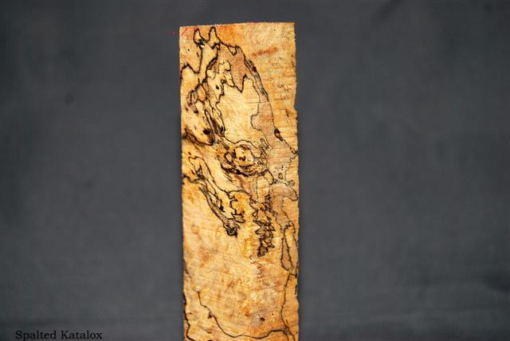 Katalox (spalted) (sapwood)  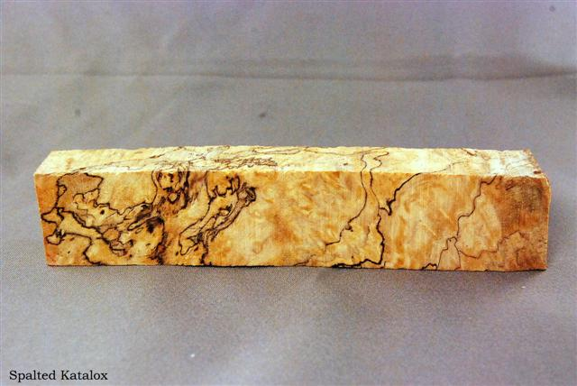 Katalox (spalted) (sapwood)
Link for a sample pen
Species of the blank
What did you like, or dislike about the blank | Like:  Dislike:
Was the blank harvested and dried by you, or kiln dried?
Does the (wood) blank need to be stabilized?
Is the wood known to be hazardous to touch, or skin?
Are the wood particles or dust known to be hazardous to inhale? (irritant, Caustic)
Did you use an alternative tool because of the nature of wood fiber to achieve a better result? (Carbide cutter tool, flap sander, etc.) ? If yes, please state
Did you use any special care for drilling?
Any special care for sanding (Dry/Wet, slow speed)?
What finish did you use? Any problems applying it?
Were there any problems with the blank after it was finished, cracks, cloudy finish,dull finish ...?
Did you use polishing or buffing?
Additional information to add
Top

- …………

- ………….

- ……….

- …………..

- …………

- …….

- ………

- ………..

Member Avatar | ??????
Blank Name | Sassafras (Spalted)
Species of the blank | Sassafras albidum
What did you like, or dislike about the blank | Like: Nery nice contrast in grain, nice aroma while turning and sanding.  Dislike: Very soft, you have to be very careful and use sharp tools.
Was the blank wet, dry, kiln dry? | Dried to 8% in food dehydrater
Does the (wood) blank need to be stabilized? | Yes. I drill the blank then soak in 50/50 mixture Lacquer/Lacquer Thinner and dry before gluing tube. Once I had the blank rough turned, I soaked with thin CA to further stabilize it before completing.
Is the wood known to be hazardous to touch? | No
Are the wood particles or dust known to be hazardous to inhale? | No
Did you use the gouge? | No
Did you use the skew? | Yes
Did you use an alternative tool? (carbide cutter tool, flap sander, etc.) ? If Yes, please sate | No
Did you use any special care for drilling? | Drill slow and clear chips frequently. On Bias and Cross cut blanks, I cut them  1/4” long and don't drill through, then cut to length.
Is the blank hard to sand? | No
What finish did you use? Any problems applying it? | CA
Were there any problems with the blank after it was finished , cracks,cloudy finish,dull finish ...? | No
Did you use polishing or buffing? | No
Additional information to add
Top

- Jjjjjjj

- Jjjjjjjjj

- Jjjjjjjjjjjjj

- Jjj

- Jjjjjjj

- Jjjjjjj

- Jjjjjjjjjjjj

Non-Wood (alternative materials) Blanks

Member Avatar | - Craftdiggity (CD) 08-30-2010, 08:59 AM  - DurocShark (DS) 09-01-2010, 09:58 AM
Blank Name (or component it is made of): | Alabaster  Variations: Alabaster (Orange Translucent), Alabaster (White Translucent), Other types include White Opaque, Red Raspberry and many others  White Alabaster (stone) (DS)
Blank picture (Before turning)
Blank picture (After rounding it.
Picture of sample pen | 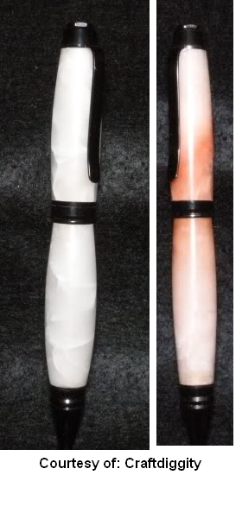  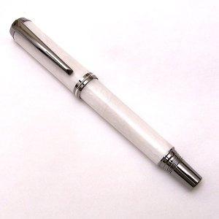 White Alabaster (stone)  courtesy of: DurocShark (DS)  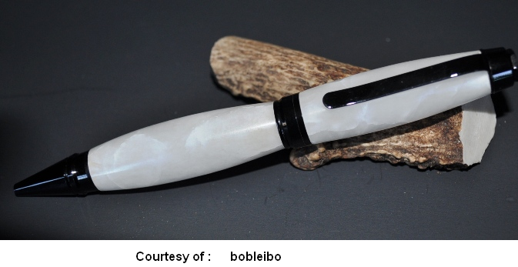
What material blank casted in or made up of? Or the other species of the blank | Species include: Alabaster (Orange Translucent), Alabaster (White Translucent)  Other types include: White Opaque, Red Raspberry and many others  Range from translucent and opaque white to Red Raspberry translucent orange to grey to red to gold and so on. (CD)
What did you like, or dislike about the blank | Like (special Characteristics):  - Unique. Real stone, not "tru-stone". Polishes beautifully. (DS)  Dislike (special Characteristics):  - Alabaster in general is very hard and cracks easily. (CD)  - WEAR RESPIRATOR!!! It generates a *lot* of dust. Cracks easily, very brittle. (DS)
Shavings or dust known be hazardous to inhale (Fumes when turning from casting materials)? | - Dust is a nuisance. (DS)  - Absolutely. Dust collection is a help, but respirators (not just a cheap mask) are imperative. (CD)
Shavings or dust hazardous to touch or skin (from casting materials)? | No+ (DS)
Tool you would recommend to use with this blank? (Gouge, scraper, flap sander, etc.) | - I use a gouge, skews and scrapers with no trouble. (CD)  - Sharpen tools frequently or use carbide tooling. Sand gently. (DS)
Any special care for drilling? | - GO very slow, but expect cracks regardless. This is stone, not wood. It is very hard and brittle and will crack no matter what you do. (CD)  - Subject to cracking if overheated(DS)
Any special care for sanding (Dry/Wet, slow speed)? | - No (CD)  - Subject to cracking if overheated (DS)
Did you apply any additional finish? | - Do not use color enhancing sealers such as granite sealers. Use only mineral oil to pop the color. No finish is necessary, but I have used a paste wax with nice results and CA seems to work fine too. (CD)  - Sanding, triple buffing. (DS)
Any problems after Blank finished (ex. cracks, cloudy, dull finish ...?, or during assembly | - no (CD), (DS)  - Cracks are a natural feature of this material. Loosen the tubes so press fitting the furniture doesn't add additional cracks. (DS)
Did you use polishing or buffing? | - Both work (CD)  - Buffing. CA can be used, but I like the natural polished look. (DS)
Additional information you like to add  Top | - I found that pressing the kit parts in can cause cracks at the ends. TO eliminate this, I file down the parts and use a drop of CA to hold them in. (CD)  - Special Note by Craftdiggity:  I work in the stone industry and I can tell you that there are literally dozens of different alabaster colors. They range from translucent and opaque white to translucent orange to grey to red to gold and so on. They all fall in a range of hardness that I would classify as brittle. They all are prone (probably more than prone) to cracking if you just look at them cross eyed. While they can be worked with woodturning tools, they all have a serious blunting effect, more so than any other wood. We're talking about three to five sharpening per pen if you're good.  In the stone industry everyone calls things by different names. Alabaster is a reference to a stone's hardness. It's a range, like marble is a much harder range and granite is another, even harder range. Within these ranges there are sometimes hundreds of different colors and even more names for these colors.

Member Avatar | - rjwolfe3 (RW) 08-30-2010, 06:05 AM  - JimMc7 (JMC) 08-31-2010, 09:23 PM  - snyiper (sny) 09-01-2010, 07:42 AM  - JBCustomPens (JBC) 09-17-2010, 12:04 PM
Blank Name (or component it is made of): | Alt. Ivory
Blank picture Before turning: | (JMC)
Link to a sample pen: | 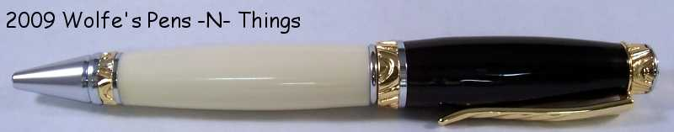 (RW) 08-30-2010, 06:01  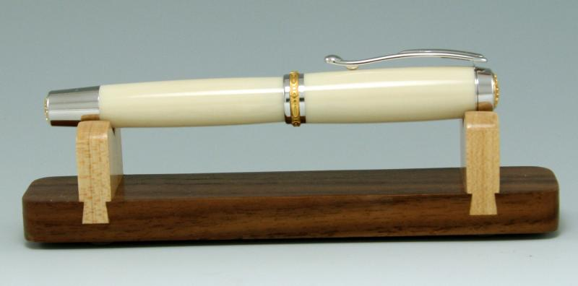  (JMC)
What material blank was casted in or made up of?
What did you like, or dislike about the blank | Like:  - Turns easily, finishes easily (RW)  - Alt Ivory is one of the easiest materials to turn in my experience. (JMC)  - Turns good, has a pleasing color. (JBC)  Dislike:  - Can chip easily (RW), (sny)  - Chips and shatters easy. (JBC)
Shavings or dust hazardous to touch or skin (I.E from casting materials)? | No (JMC) (sny), (JBC)
Shavings or dust known be hazardous to inhale, or fumes from casting materials when Turning? | - use DC and/or dust mask (RW), (JMC)  - particles are fine use mask (sny)  - I'd use a dust mask and/or dc. (JBC)
Tool you would recommend to use most to achieve the best results with this blank? (Gouge, scraper, carbide tool, etc.?): | - I prefer carbide but a skew works great (RW)  - I do prefer using a skew (JMC)  - I use a skew and a carbide (sny)  - Spindle Gouge and skew. (JBC)
Any special care for drilling?: | - drill slow (RW), (JMC), (sny)  - Drill slow, lube with wd-40 or mineral oil. (JBC)
Any special care for sanding (Dry/Wet, slow speed)? | wet sand (RW), (JMC), wet sand (sny), (JBC)
What finish did you use? Any problems applying it? | - None (RW), (JMC) none  - Plastic polish. (JBC)
Were there any problems with the blank after it was finished, cracks, cloudy finish, dull finish ...? | No (RW), (JMC), (sny), (JBC)
Did you use polishing or buffing? | - polish and/or buff (RW), (JMC)  - polish on lathe never dull (sny)  - Polished on lathe with rag. (JBC)
Additional information to add  Top | - Makes great wedding pens (RW)  - Ditto to what Rob said.... , (JMC)  - Makes great tops for bullet pens (sny)  - Nice material, good color. (JBC)

Member Avatar | Wolftat
Blank Name (or component it is made of): | Casein
Blank picture (Before turning)
Blank picture (After rounding it.
Link to a sample pen | 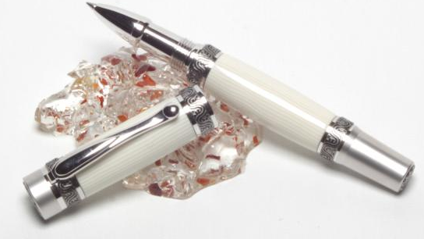 Courtesy of Wolftat
What did you like, or dislike about the blank | Like (special Characteristics):  Dislike (special Characteristics):
What material blank casted in or made up of?
Shavings or dust known be hazardous to inhale Fumes when turning)(from casting materials)?
Shavings or dust hazardous to touch or skin (from casting materials)?
Any special care for drilling?
Any special care for sanding (Dry/Wet, slow speed)?
Tool you would recommend to use with this blank? (Gouge, scraper, flap sander, etc.)
Did you apply any additional finish
Any problems applying it
Any problems after Blank finished (ex. cracks,cloudy, dull finish ...?
Did you use polishing or buffing?
Additional information you like to add

Top

Member Avatar | - hunter-27 (H27) 09-10-2010, 09:28 PM  - Bellsy (BE) 09-13-10 , 08:44 PM
Blank Name (or component it is made of): | Corn Cob
Blank picture (Before turning)
Blank picture (After rounding it. | 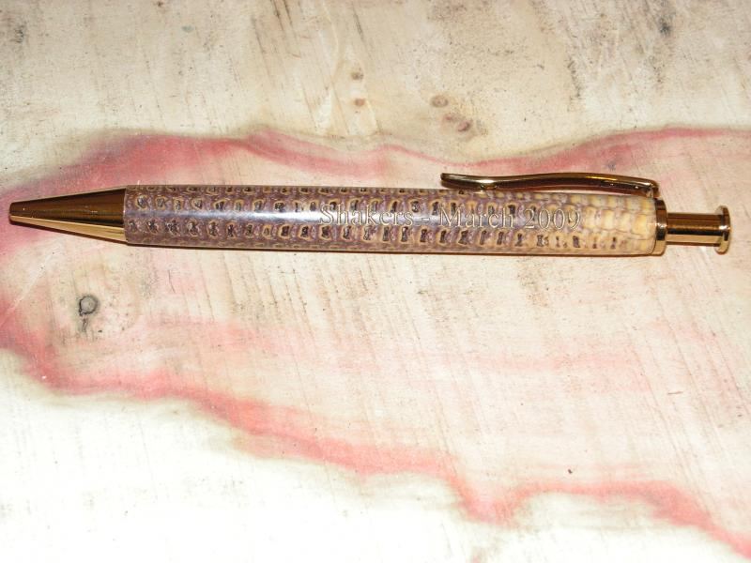  Pic.s Courtesy of: hunter-27 (H27)  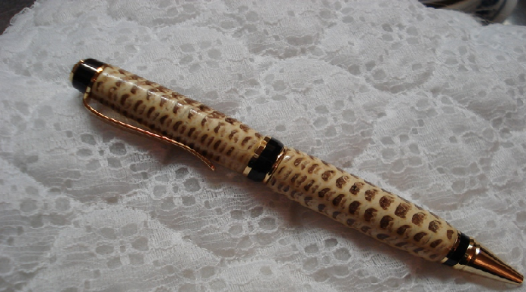  Red oak stain added. courtesy of Bellsy (BE)  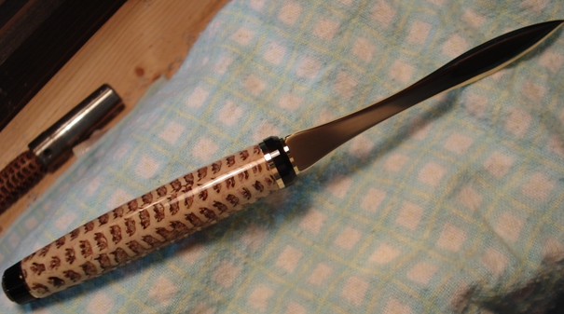 courtesy of Bellsy (BE)
Link to a sample pen
What did you like, or dislike about the blank | Like (special Characteristics):  Unique look, few customers recognize in a pen form  Dislike (special Characteristics):  can be a bit brittle to work
What material blank casted in or made up of?
Shavings or dust known be hazardous to inhale Fumes when turning)(from casting materials)? | No worse than other dust unless it has stabilizing agents in it. Some of those can be very bad for you.
Shavings or dust hazardous to touch or skin (from casting materials)? | no
Any special care for drilling? | Drill carefully to not blow it out. Don’t drill clear through, leave long and cut back to the proper length.
Any special care for sanding (Dry/Wet, slow speed)? | I dry sand it with my usual pattern through MM 12000 and then polish with Brasso
Tool you would recommend to use with this blank? (Gouge, scraper, flap sander, etc.) | Carbide or skew
Did you apply any additional finish | - CA  - I use the CA to form a paste with the swarf from the cob and reapply it to the voids created by manually removing the remaining kernels from the cob. Once I have filled in all of the voids (holes) I turn the cob down to it's final size and shape. The cob is then sanded to @ 600 - 800 grit and then I add the final layers of CA to finish the pen. The final finish is sanded to 120000 MM and polished with Huts Plastic Polish.
Any problems applying it
Any problems after Blank finished (ex. cracks, cloudy, dull finish ...? | no
Did you use polishing or buffing? | Polish with Brasso
Additional information you like to add  Top | - Stabilize professionally or use CA  - I do want to add that adding CA to a cob in my opinion is not stabilizing as we know it to be. If this was so, then adding CA to any pen could be considered stabilizing. One could also say that adding CA back to a corn cob is a form of casting......but that's just my opinion.

Member Avatar | Rangertrek (RT), 8/10/10-- (JU),
Blank Name | Deer Antler
What did you like, or dislike about the blank | Like (special Characteristics): variations in the finished, polished blank, mult shades, textures (RT),  Dislike (special Characteristics):smell when cutting and turning, sometimes a challenge to drill a straight hole. (RT),
Was the blank harvested and dried by you? | I have both my own and provided blanks, some less than a year old, and others over 2+ years old. (RT),
Blank needs be stabilized? | small voids need to be filled during turning (RT),
Particles or dust known be hazardous to inhale, touch or skin?(irritant)(smelly) | antler is an animal product and should be handled that way, latex gloves, and respirator recommended, smelly and an irritant(RT),
Did you use an alternative tool because of the nature of antler to achieve a better result? (Carbide cutter tool, flap sander, etc.) ? If yes, please state | Standard lathe tools work well (RT),
What do you do if it has some curve to it (how do you make it straight)? | I use a Plexiglas gauge to layout the sections to be cut. Marking on the gauge show length needed and diameter of the drill hole (brass tube). If both appear to fit the section, cut off longer than needed. Mark approx location of centers, using the gauge lines, drill on lathe (RT),
Any special care for drilling? | See above (RT),  Just don't get them too hot(JU),
Any special care for sanding (Dry/Wet, slow speed)? | sand like a stand acrylic blank, wet methods, small cracks may need to be filled (RT),  Just don't get them too hot(JU),
What finish did you use? Any problems applying it? | ca finish to fill pores, etc. micromesh, polish (RT),
Were there any problems with the blank after it was finished, cracks, cloudy, and dull finish ...? | not usually (RT),
Did you use polishing or buffing? | Polish (RT),
Additional information you like to add:  Top | I don't usually worry about trying to straighten antler, but I cut my own so I can plan where I want it curved which helps in leaving some natural antler surface (some call it bark). It adds a little difficulty to the process but will really add to the finished look. It's just hard to make larger pens with the curved pieces. I like to make euros and comfort style pens with them because the 7mm hole is a bit easier to pull off with no blowouts while drilling, but I drill on the drill press holding the pieces with pliers after I draw pencil lines on the side to line up with the bit and help guide me. (JU),

Member Avatar, picture | JBCustomPens (JBC) 8/16/10 10:52 AM
Blank Name | Ebonite
Link to a finished pen | http://www.penturners.org/forum/atta...4&d=1278550543 (JBC)
What did you like, or dislike about the blank | Like: (special Characteristics)  - Awesome swirls (JBC)  Dislike: (special Characteristics)  - Stinks like mad. (JBC)
Blank needs be stabilized? | No. (JBC)
Shavings or dust hazardous to touch or skin? | No. (JBC)
Shavings or dust known be hazardous to inhale? | I'd wear a dust mask. (JBC)
Tool you would not recommend to use with? (gauge, carbide cutter tool, flap sander, etc.) | None. Overall anything sharp will do. (JBC)
Any special care for drilling? | Drill slow, lube with WD40 or mineral oil. (JBC)
Any special care for sanding (Dry/Wet, slow speed)? | Dry or wet sanding both work, I used wet. (JBC)
Finish used? | MM to 12000, plastic polish. (JBC)
Any problems applying it? | No. (JBC)
Any problems after Blank finished (ex. cracks, cloudy, dull finish ...? | No. (JBC)
Used polishing or buffing? | Just on the lathe with a soft cloth. (JBC)
Additional information you like to add  Top | Great material to work with if you are patient and don't mind the smell. It may be too expensive for some, as mine was over $20 for the 6 inch blank. (JBC)

- …

Top

- …….

- ………

Top

Member Avatar | - ldb2000 (ID2) 09-20-10, 06:28 AM  - arioux (AR) 09-20-10, 07:01 AM  - HSTurning (HS) 09-20-10, 01:56 PM
Blank Name (or component it is made of): | Inlace Acrylester
Blank picture (Before turning)
Blank picture (After rounding it.
Link to a sample pen | 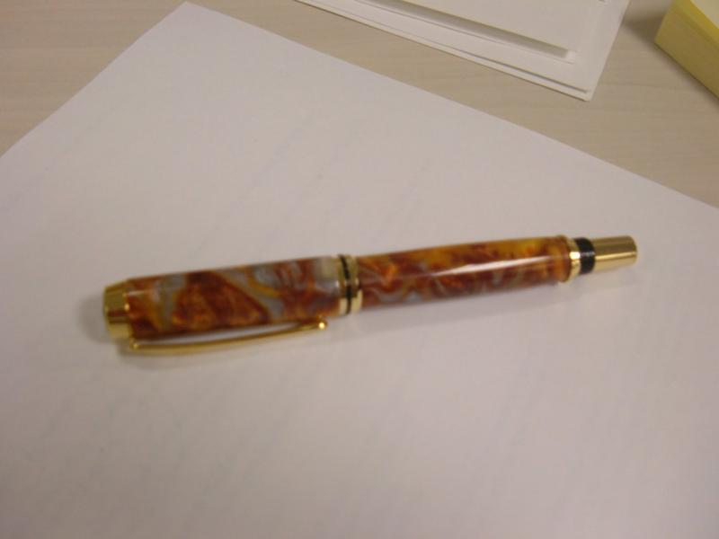  Molten Metal blank, Courtesy of BigguyZ
Variation of the blank | Molten Metal blank,
What did you like, or dislike about the blank | Like (special Characteristics)  - They are my favorite blanks to turn; they polish to a higher shine then any other blank out there. (ID2)  - I really enjoy working with this material (HS)  Dislike (special Characteristics)  - They are a little very brittle arioux,  - Some people feel it's too brittle (ID2)  - Some colors seam more brittle then others (HS)
What material blank casted in or made up of? | Inlace Acrylester is a type of Polyester Resin (ID2)
Shavings or dust known be hazardous to inhale Fumes when turning)(from casting materials)? | Any dust is bad for you(ID2)
Shavings or dust hazardous to touch or skin (from casting materials)? | No (ID2)
Any special care for drilling? | - Drill the blank sections but not quite all the way through, then trim them to reveal the hole. Otherwise, the risk of a drill blowout is high. workinforwood  - Drill with a slow speed and keep backing out bit to clear cuttings from hole , Cut blank extra long and cut to length after drilling to avoid blow outs when bit exits blank (ID2)
Any special care for sanding (Dry/Wet, slow speed)? | - If you have a belt or drum sander, try sanding off the edges, this will help you to start if you are not too confident with you tool arioux  - Use a high quality sandpaper , avoid coarse grits , I don't wet sand but it might help some people (ID2)  - Abernet to rough sand. Wet sand MM (HS)
Tool you would recommend to use with this blank? (Gouge, scraper, flap sander, etc.) | - Sharp tools, arioux  - Light touch and sharp tools" are extra important. Very sharp Skew using a shearing cut is best (ID2)  - I use a hunter #4 to rough and sometimes finish. Skew to finish most of the time. (HS)
Did you apply any additional finish | No (ID2)
Any problems applying it | No (ID2)
Any problems after Blank finished (ex. cracks, cloudy, dull finish ...? | No (ID2)
Did you use polishing or buffing? | I polish with plastic/metal polish on the lathe and then buff with white diamond on a soft flannel buff on my drill press (ID2)
Additional information you like to add:  Top | - Sharp tools, light touch and the rest is like any other acrylics  Depending on the color, you might want to paint your tube too. arioux  - Inlace Acrylester is a translucent material you must paint the inside of the blank to avoid the brass tubes from showing when turned. It is a very brittle material so sharp tools and a very light touch is required, learn how to ride the bevel with your tools and you will have no problems. It polishes to a very high shine when buffed (I personally feel it has the highest shine of any acrylic) (ID2)  - Not a bad idea to cut the blank longer than you need it to be. Workinforwood  - Don’t drop onto hard floors. I have dropped a few onto my concrete floor and most have chipped. One had 3/4" break off. Clear tubes of any epoxy/ CA before installing parts. I didn’t ream the end of some slim lines and have a "cracked glass" look about 1/4 to 1/2 way down the blanks. (HS)

- ….
- ……..

Member Avatar | hunter-27 (H27) 08-15-2010, 08:40 PM
Picture | 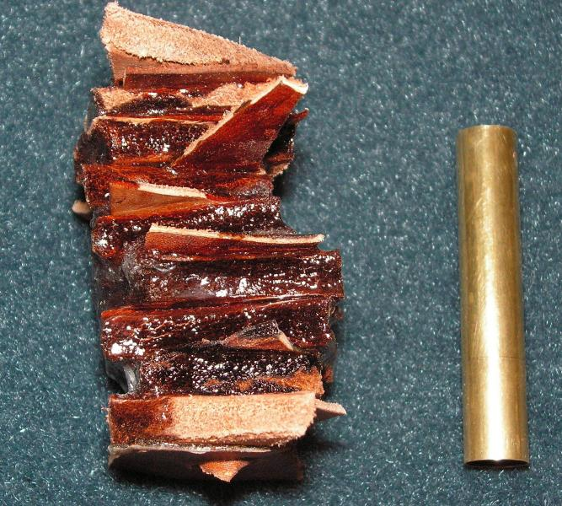 picture before, courtesy of (H27)  Picture after drilling,  courtesy of (H27)
Blank Name | LEATHER
Link to a finished pen | 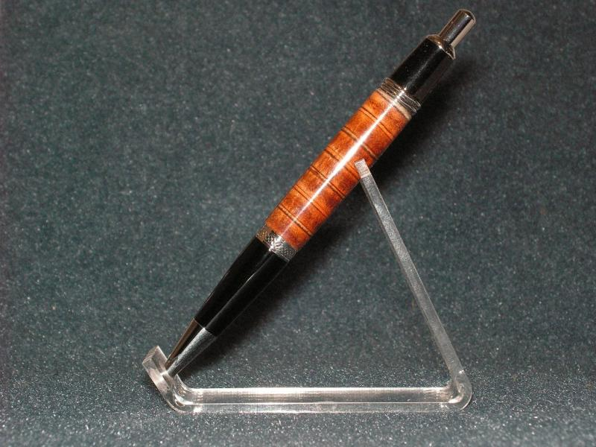 courtesy of (H27)
likes or dislikes about the blank | - likes--different look from anything else,  - Dislikes-- time consuming to cut the leather and glue it together
Blank needs be stabilized? | yes
Shavings or dust hazardous to touch or skin? | no
Shavings or dust known be hazardous to inhale? | don't think it would be especially good for you but no known effects
Tool you would not recommend to use with? (gauge, carbide cutter tool, flap sander, etc.) | Skew
Any special care for drilling? | Drilling leather is not easy, the leather grabs the bit horribly
Any special care for sanding (Dry/Wet, slow speed)?
Finish used? | CA finish, CA to glue the layers, CA to fill the voids
Any problems applying it? | leather drinks ca
Any problems after Blank finished (ex. cracks, cloudy, dull finish ...? | CA darkens the leather, not a bad thing but it is a consideration when choosing the leather
Used polishing or buffing? | MM through 12000, then use Brasso as with all my CA finishes or acrylic blanks
Additional information you like to add  Top | While it is fun to do once or twice I have no huge desire to go into mass production of this type of blank.

- ….

Member Avatar | WHSKYrvr1(WHS) 8-23-10 9:14 pm
Blank Name | M3 Cobalt Blue
Species of the blank
What did you like, or dislike about the blank | Like: It turns a lot like hard plastic, sharp tools are a must.  Dislike: It has a strong odor when drilling and sizing blanks. Good ventilation is a mist.
Was the blank wet, dry, kiln dry? | N/A
Does the (wood) blank need to be stabilized? | no need to be stabilized
Is the wood known to be hazardous to touch? | No rash or allergies (for me) Not hazardous that I know of. It is recommended to use gloves during polishing
Are the wood particles or dust known to be hazardous to inhale? | It is recommended to wear a dusk mask while turning and sanding.
Did you use the gouge? | Yes
Did you use the skew? | Yes
Did you use an alternative tool? (carbide cutter tool, flap sander, etc.) ? If Yes, please sate | Carbide sharp skew for finish cut. And Carbide gouge for roughing in
Did you use any special care for drilling? | DO NOT OVERHEAT, just go slow. It does heat quickly.
Is the blank hard to sand? | No
What finish did you use? Any problems applying it? | I used the finishing compound that PennState Industries sold.
Were there any problems with the blank after it was finished , cracks,cloudy finish,dull finish ...? | No problems so far
Did you use polishing or buffing? | No
Additional information to add
Top

Member Avatar | Toni (TO)
Blank Name | Polymer Clay
Blank Name (or component it is made of):
Blank picture (Before turning) | 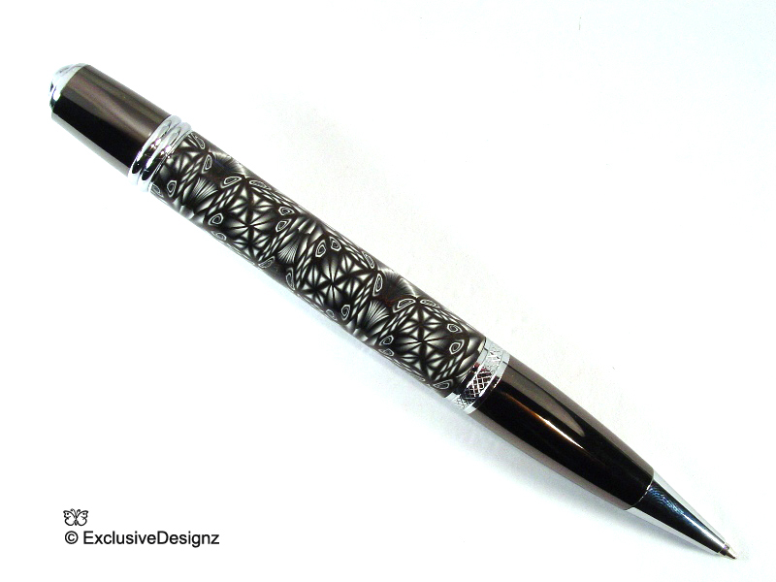
Blank picture (After rounding it.
Blank needs be stabilized? | NO
Shavings or dust hazardous to touch or skin? | No, best to wet sand to keep the dust under control
Shavings or dust known be hazardous to inhale? | NO
Tool you would not recommend to use with? (gauge, carbide cutter tool, flap sander, etc.) | Carbide cutter Tool
Any special care for drilling?
Any special care for sanding (Dry/Wet, slow speed)? | Wet Sand
Finish used? | CA
Any problems applying it? | NO
Any problems after Blank finished (ex. cracks, cloudy, dull finish ...? | NO
Used polishing or buffing? Buffing
Additional information you like to add  Top | Turns like butter, comes off in ribbons

Top

Contributors List: Top

- Alexanderpens (AP), Arioux (AR),

- bitshird (BIS), BigguyZ (BZ) Blue Danube (BD), bradh (BR), bruce119(BR1)

- CSue (CS), Craftdiggity (CD),

- David Keller (DK), DCBluesman (DCB), diver123 (DIV), DurocShark (DS)

- EBorraga (EB), ed4copies (ED),

- fyrcaptn (FC),

- gr8danish (GD), Glenn McCullough (GM),

- hilltopper46 (HT) , HSTurning (HS), Hucifer (HU), hunter-27 (H27)

- ldb2000 (ID2),

- JBCustomPens (JBC), JimMc7 (JMC), JohnU (JU),

- KenV (KV)

- L

- Mark (MK), MatthewZS (MZS), Midi (MID), Mickey (MIK)

- N

- O

- Penmanship (PM), phillywood (PW),

- Q

- Rangertrek (John Carlisle) (RT), rjwolfe3 (RW), RyanNJ (RNJ)

- Seer(SR), Scotty (SC), snyiper (sny), Soligen (SOL), SteveG (SG)

- tim self (TS), ToddMR (TM), Toni (TO)

- u

- v

- WHSKYrvr1(WHS), writeitdown (WD), wdcav1952 (WCAV)

- X

- Y
- Top

✓
Following sites where contributed by following members:

8/10/2010 | fyrcaptn (FC) | http://hobbithouseinc.com/personal/w...indextotal.htm
8/9/2010 | Midi (MID), & (BR) | oily and difficult woods:  http://www.wood-database.com/wood-ar...cal-hardwoods/  The International Wood Collectors Society  home page: home page: http://www.woodcollectors.org/  list of specimens:  http://www.woodcollectors.org/pdf/wo...cimen-list.pdf

Top

